INTERNSHIP PROJECT REPORT
TOPIC
RTL TO GDSII Flow at 45 nm gpdk on
CADENCE TOOLS

Submitted by : DURGESH GUPTA
Under the Guidance of
Dr. Gaurav Trivedi,
Principle Investigator,
Novel Integrated Electronics(NINE) Labs,
Under Ministry of Electronics and Information Technology(MeitY),India




Indian Institute of Technology Guwahati, Assam - 781039

Acknowledgement

I would like to extend my sincere gratitude to Indian Institute of Technology , Guwahati for providing me with the opportunity to complete my internship and for the invaluable support throughout my time here.
First and foremost, I wish to express my deepest appreciation to my supervisor, Dr. Gaurav Trivedi , for his unwavering support, guidance, and mentorship. His expertise and insights in the field of Physica Design were crucial in the successful completion of this report.
I am also grateful to Dr. Amol Boke , my mentor, for their constant encouragement and for providing me with numerous learning opportunities. Their feedback and advice significantly enhanced my understanding and skills.
I would like to acknowledge the assistance of the Nine Labs team, for their collaboration and for making my internship experience enriching and enjoyable.
Special thanks go to Dr. N. Y. Meitei for his support in RTL Designs.
I am also thankful to the Electronics and ICT Academy ,IIT Guwahati, for providing the necessary resources and facilities that enabled me to conduct my work effectively.
Finally, I am grateful to all the staff and interns at IIT,Guwahati for creating a welcoming and conducive environment for learning and professional growth.

Thank you all for making my internship experience both rewarding and memorable.

DECLARATION

I hereby declare that:
1. The work contained in this report is original and has been completed by myself
under the general supervision of my supervisor.
2. This work has not been submitted to any other Institute for any degree or diploma.
3. I have adhered to the guidelines provided by the NINE Labs, IIT Guwahati in writing the thesis.
4. I have conformed to the norms and guidelines provided in the Ethical Code of
Conduct of NINE Labs ,IIT Guwahati.
5. Whenever I have used materials (data, theoretical analysis, and text) from other
sources, I have given due credit to them by citing them in the text of the report
and providing their details in the references.
6. Whenever I have quoted written materials from other sources, I have put them
under quotation marks and given due credit to the sources by citing them and
providing the required details in the references

Signature:


__________________________

Name : Durgesh Gupta
Roll Number : 1181700149
Date : 24/06/2024
Contents

1. Introduction.......................................................................................................7
* 1.2 Introduction to RTL Design and RTL to GDS II Flow
* 1.1 Introduction to Linux Ubuntu and Vim Editor
2. Literature Review and Objectives...................................................................12
* RTL Design
* Physical Design
* Objectives
3. Design Methodology..........................................................................................16
3.1 RTL Design ...................................................................................20
* 4:1 MUX using 2:! MUX
* Traffic Light Controller
* Complex Multiplier
* Ripple Carry Adder
3.2 Synthesis Using Genus Common UI...........................................28
* LAB1 : Base Lab for Genus
* LAB 2 : DFT Flow
8 LAB 3 : Runnig Low Power synthesis
3.3 Basic Floorplanning in Innovus using Stylus Common UI.......33
* Design Floorplan
* Connection between Parent Module and Child Instance
* ram0/ram0 connection to other macros
* Complete Floorplan
* Finished Floorplan
* Power Rings
* coreinst/ks_core1/periph_PH block with power rings
* Horizontal Power and Ground Stripes
* Design after creating power rails
3.4 Block Implementation Flow using Stylus Interface of Innovus...40
* Imported Design
* Place Design
* 2-D view of Early Global Congestion
* Timing Debug Display
* Clock Tree Debugger (CTD )
* CTD colour by Transition Time
* Instance or Net view in Debugger
* Clock tree Display
* Clock Tree Display ( No Colour )
* Clock Tree Display Max Path Highlight
* Clock Tree Display Min Path Highlight
* Post Route Timing and SI Optimization
* Post Route Setup Timing
* Post Route Hold Timing
* 3-D Layout of Design
* Design Verification
* Violation Browser View
* Violation Solved

4. Results and Discussions..................................................................................59
4.1 Test Bench for RTL Designs........................................................59
* Full Adder
* Full Subtractor using Full Adder
* Ripple Carry Adder
* 4:1 MUX using 2:! MUX
* Traffic Light Controller
* Complex Multiplier
* Ripple Carry Adder
4.2 Post Synthesis and Post Implentation table of RTL Designs...63
* Full Adder
* Full Subtractor using Full Adder
* Ripple Carry Adder
* 4:1 MUX using 2:! MUX
* Traffic Light Controller
* Complex Multiplier
* Ripple Carry Adder
4.3 RTL Design Synthesis Comparison Reports..............................66
* dtmf reciever core
* Traffic Light Controller
* AMBA APB Bridge
4.4 Timing Analysis Report in PnR..................................................84
* SET UP Timing :
> Pre CTS
> Post CTS
> Post ROUTE

* Hold Timing :
> Pre CTS
> Post CTS
> Post ROUTE

5. Conclusion and Future Scope.........................................................................89

6. References.........................................................................................................91

1. Introduction

1.1 Introduction to Linux Ubuntu and Vim Editor
In the world of computing, Linux has emerged as a dominant force, known for its robustness, flexibility, and open-source nature. Among the various distributions of Linux, Ubuntu stands out for its user-friendliness and widespread adoption. Complementing this powerful operating system, the Vim editor provides a versatile and efficient tool for text editing, catering to both beginners and advanced users. This introduction aims to provide an overview of Ubuntu and Vim, highlighting their features, benefits, and roles in the computing landscape.

Linux Ubuntu
Ubuntu is a popular Linux distribution developed and maintained by Canonical Ltd. It is renowned for its ease of use, making it a preferred choice for both newcomers and experienced users in the Linux ecosystem. Ubuntu is built on the Debian architecture and offers a user-friendly interface, extensive software repositories, and robust community support.
Key Features of Ubuntu:
- User-Friendly Interface: Ubuntu provides a clean and intuitive graphical user interface (GUI), with the GNOME desktop environment as its default.
- Software Repositories: It offers access to a vast collection of software packages through its repositories, enabling easy installation and updates.
- Security: Ubuntu emphasizes security, with regular updates, a strong firewall, and built-in security features like AppArmor.
- Customizability: Users can customize the desktop environment, themes, and settings to suit their preferences.
- Community Support: Ubuntu has a large and active community that provides extensive documentation, forums, and online resources to assist users.
Benefits of Using Ubuntu:
- Open Source: Ubuntu is free to use, modify, and distribute, fostering innovation and collaboration.
- Stability and Reliability: Known for its stability, Ubuntu is widely used in servers, desktops, and cloud environments.
- Wide Hardware Compatibility: Ubuntu supports a broad range of hardware, making it suitable for various devices, from desktops to embedded systems.

Vim Editor
Vim, short for "Vi IMproved," is a highly configurable text editor built to enable efficient text editing. Vim is an enhanced version of the classic Vi editor, offering numerous features that make it powerful yet lightweight.
Key Features of Vim:
- Modal Editing: Vim uses different modes for inserting text, navigating, and manipulating text, enhancing editing efficiency.
- Extensibility: Vim can be extended with plugins and customized with scripts to fit the user's workflow.
- Syntax Highlighting: Supports syntax highlighting for numerous programming languages, improving code readability.
- Powerful Search and Replace: Vim offers robust search and replace functionalities with support for regular expressions.
- Keyboard-Centric Operation: Vim is designed for use without a mouse, allowing users to perform complex editing tasks using keyboard shortcuts.
Benefits of Using Vim:
- Speed: Vim's modal editing and command shortcuts enable rapid text manipulation, boosting productivity.
- Resource Efficiency: Vim is lightweight and can run on virtually any system, from powerful servers to low-resource devices.
- Versatility: Suitable for a wide range of text editing tasks, from simple note-taking to complex coding projects.
- Learning Curve: While Vim has a steep learning curve, mastering it provides a significant advantage in text editing efficiency.

Conclusion
Ubuntu and Vim represent two pillars of the open-source software world, each excelling in its domain. Ubuntu offers a stable, user-friendly Linux distribution that caters to a broad audience, while Vim provides a powerful and efficient text editing tool for users who seek to maximize their productivity. Together, they form a compelling combination for developers, system administrators, and anyone looking to leverage the power of open-source software in their computing endeavors.

1.2 Introduction to RTL Design and RTL to GDS II Flow
The design and fabrication of digital integrated circuits (ICs) are intricate processes that transform conceptual ideas into physical devices capable of performing complex computational tasks. At the heart of this transformation lies the Register Transfer Level (RTL) design and the subsequent RTL to GDS II flow, a well-defined sequence of steps that convert a high-level hardware description into a manufacturable silicon chip.

RTL Design
RTL design is the initial phase of digital IC design where the functionality of the circuit is described at a high level using Hardware Description Languages (HDLs) such as Verilog or VHDL. At this stage, designers specify how data moves between registers and how the logic operations are performed on the data. RTL design focuses on the synchronous aspects of the circuit, detailing the interaction between combinational logic and clocked storage elements (flip-flops).
The primary goals of RTL design include:
- Functional Specification: Accurately capturing the intended behavior of the digital system.
- Hierarchical Structuring: Organizing the design into manageable blocks or modules.
- Simulation and Verification: Ensuring that the RTL description correctly implements the desired functionality through extensive simulation and testing.
RTL design serves as the blueprint for the subsequent stages of the design flow, setting the foundation for translating abstract functionality into concrete hardware.

RTL to GDS II Flow
The RTL to GDS II flow is a critical and complex process that takes the RTL design through various stages of refinement and verification, ultimately producing a detailed physical layout that can be manufactured on a silicon wafer. This flow encompasses several key stages:
- Synthesis: Translating the RTL code into a gate-level netlist that represents the design in terms of logic gates and flip-flops.
- Design for Testability (DFT): Inserting test structures to facilitate efficient post-manufacturing testing of the IC.
- Floorplanning: Defining the physical layout and placement of major functional blocks within the chip.
- Placement: Optimally placing individual standard cells within the floorplan.
- Clock Tree Synthesis (CTS): Designing a robust clock distribution network to ensure synchronized operation of the circuit.
- Routing: Connecting the placed cells according to the netlist, using metal layers to form the necessary interconnections.
- Signoff Verification: Performing various checks such as Static Timing Analysis (STA), Design Rule Checking (DRC), Layout Versus Schematic (LVS), and power analysis to ensure the design meets all specifications.
- Physical Verification: Final checks to ensure manufacturability and performance.
- Tape-out: Generating the final GDS II file, which contains the complete physical layout of the chip ready for fabrication.
Each stage of the RTL to GDS II flow involves specialized tools and methodologies, addressing specific aspects of the design to ensure functionality, performance, and manufacturability. This meticulous process is crucial for producing reliable and efficient ICs that power a wide range of electronic devices.

Conclusion
The journey from RTL design to GDS II is a testament to the intricacy and sophistication of modern digital IC design. By systematically progressing through each stage of the RTL to GDS II flow, designers can transform high-level functional descriptions into tangible, high-performance silicon chips. Understanding this flow is essential for anyone involved in the field of digital design, providing the knowledge and skills necessary to bring innovative electronic solutions to life.

2. Literature Review and Objectives

RTL Design

Overview
RTL design is a high-level abstraction used in the design of digital circuits. It describes the operation of a circuit in terms of the data flow between registers and the logical operations performed on this data. RTL design is essential for the synthesis of digital circuits and forms the basis for subsequent stages of the IC design process.

Key Concepts
- Hardware Description Languages (HDLs):
  - HDLs such as VHDL and Verilog are commonly used for RTL design. These languages allow designers to describe the behavior and structure of electronic systems at a high level of abstraction.
- Synthesis:
  - The process of converting RTL descriptions into gate-level netlists. Tools like Synopsys Design Compiler and Cadence Genus are widely used for synthesis.

Methodologies and Techniques
- High-Level Synthesis (HLS):
  - HLS tools automate the generation of RTL code from high-level algorithms written in languages like C/C++. This approach accelerates the design process and allows for early design space exploration.
- Formal Verification:
  - Ensures the correctness of RTL designs by mathematically proving that the design adheres to its specification. Tools like Cadence JasperGold and Synopsys Formality are used for this purpose.

Challenges
- Complexity Management:
  - Managing the complexity of modern IC designs, which can contain billions of transistors, is a significant challenge. Modular design and reusable IP cores are strategies employed to address this issue.
- Power Optimization:
  - Power efficiency is critical in modern ICs, especially for battery-operated devices. Techniques like clock gating, power gating, and multi-voltage design are employed at the RTL level to minimize power consumption.

Physical Design

Overview
Physical design is the process of translating a logical representation of a circuit into a physical layout. This stage involves placement, routing, and optimization to ensure the circuit meets performance, area, and power specifications.

Key Concepts
- Floorplanning:
  - Determines the placement of major functional blocks within the IC. Effective floorplanning is crucial for meeting timing and area constraints.
- Placement and Routing:
  - Placement involves assigning precise locations to standard cells, while routing connects these cells with metal wires. Tools like Cadence Innovus and Synopsys ICC2 are commonly used for placement and routing.
- Timing Analysis:
  - Ensures that the circuit meets its timing requirements. Static timing analysis (STA) tools like Synopsys PrimeTime and Cadence Tempus are used to verify that all paths in the circuit meet their timing constraints.

Methodologies and Techniques
- Design for Manufacturability (DFM):
  - Techniques to ensure that the design can be reliably manufactured. This includes checking for lithography issues, via optimization, and redundant vias.
- Clock Tree Synthesis (CTS):
  - Ensures that the clock signal is distributed evenly across the entire IC, minimizing skew and jitter. Effective CTS is critical for meeting timing requirements.

Challenges
- Process Variability:
  - Variations in the manufacturing process can lead to differences in the performance of ICs. Techniques like statistical timing analysis and adaptive body biasing are used to mitigate the impact of process variability.
- Thermal Management:
  - Managing the heat generated by high-performance ICs is crucial to prevent thermal-induced failures. Thermal-aware design techniques and advanced cooling solutions are employed to address this issue.

Conclusion
The fields of RTL design and physical design are integral to the development of modern integrated circuits. Continuous advancements in tools and methodologies are driving improvements in performance, power efficiency, and manufacturability. However, challenges such as managing design complexity, optimizing power consumption, and addressing process variability remain critical areas of research and development. This literature review highlights the importance of these stages in the IC design process and underscores the ongoing efforts to enhance design techniques and tools.

Objectives of the Report

The primary objectives of this report are:
- To document the hands-on experiences and tasks completed during the internship.
- To provide an in-depth understanding of the RTL design and physical design processes.
- To highlight the tools and techniques used in both stages of IC design.
- To discuss the challenges encountered and the solutions implemented during the design process.
- To reflect on the learning outcomes and their relevance to future career prospects in IC design.
This report aims to provide a comprehensive account of my internship journey, showcasing the skills acquired and the knowledge gained in RTL and physical design. By documenting this experience, I hope to contribute valuable insights to the ongoing discourse in the field of IC design and inspire future interns embarking on similar paths.

3. Design Methodology

Design Methodology in Physical Design
Physical design is a critical phase in the development of integrated circuits (ICs), where the high-level logical design is translated into a physical layout that can be manufactured. This process involves several stages, each with specific tasks and objectives. The goal is to optimize the layout for performance, power consumption, and area while ensuring manufacturability. Here, we explore the key steps and methodologies involved in physical design.

Key Stages in Physical Design
- Floorplanning
  - Objective: Define the placement of major functional blocks within the chip.
  - Process: During floorplanning, designers decide on the size, shape, and relative positions of various blocks. This step sets the stage for effective placement and routing by minimizing wire lengths and ensuring that timing and power requirements can be met.
  - Tools: Tools like Cadence Innovus, Synopsys IC Compiler, and Mentor Graphics Olympus-SoC are commonly used.
- Placement
  - Objective: Assign precise locations to standard cells within the blocks defined during floorplanning.
  - Process: Placement involves arranging the standard cells in a way that meets design constraints for timing, power, and area. The placement must also consider routing congestion to ensure that wires can be efficiently laid out.
  - Techniques:
    - Global Placement: Provides an initial, rough placement of cells.
    - Detailed Placement: Fine-tunes the placement to resolve any overlaps and optimize local areas.
  - Tools: Cadence Innovus, Synopsys ICC2, and Mentor Graphics Olympus-SoC.
- Clock Tree Synthesis (CTS)
  - Objective: Distribute the clock signal evenly across the chip to minimize skew and jitter.
  - Process: CTS involves creating a hierarchical tree structure that balances the clock load and ensures that the clock signal reaches all parts of the chip simultaneously.
  - Challenges: Managing clock skew, jitter, and power consumption are critical during CTS.
  - Tools: Synopsys PrimeTime, Cadence Tempus, and Innovus.
- Routing
  - Objective: Connect all the placed cells with metal wires according to the netlist while meeting design constraints.
  - Process: Routing is typically done in two stages:
    - Global Routing: Determines the overall routing paths and congestion areas.
    - Detailed Routing: Precisely defines the routes for each wire.
  - Techniques:
    - Layer Assignment: Assigns different layers for horizontal and vertical routes to reduce interference.
    - Timing-driven Routing: Ensures that timing constraints are met during routing.
  - Tools: Cadence Innovus, Synopsys ICC2, and Mentor Graphics Calibre.
- Physical Verification
  - Objective: Ensure that the layout meets all design rules and specifications.
  - Process: This involves checking the layout against design rule checks (DRC), layout versus schematic (LVS), and electrical rule checks (ERC).
  - Challenges: Ensuring manufacturability and functionality while adhering to foundry-specific rules.
  - Tools: Mentor Graphics Calibre, Synopsys IC Validator, and Cadence Pegasus.
- Sign-off
  - Objective: Final verification and validation of the design before tape-out.
  - Process: This stage includes comprehensive timing analysis, power analysis, and signal integrity checks to ensure the design meets all performance and reliability requirements.
  - Tools: Synopsys PrimeTime for timing analysis, Apache RedHawk for power analysis, and Cadence Tempus for signal integrity.

Methodologies and Techniques
- Design for Manufacturability (DFM)
  - Objective: Optimize the layout to ensure it can be reliably manufactured.
  - Techniques: Involves lithography simulation, critical area analysis, and the use of redundant vias to improve yield.
  - Tools: Mentor Graphics Calibre, Cadence Litho Physical Analyzer.
- Low Power Design
  - Objective: Minimize power consumption while meeting performance goals.
  - Techniques: Multi-Vt cells, power gating, clock gating, and dynamic voltage and frequency scaling (DVFS).
  - Tools: Synopsys Power Compiler, Cadence Voltus.
- Thermal Management
  - Objective: Manage heat dissipation to prevent thermal-induced failures.
  - Techniques: Thermal-aware floorplanning, use of thermal vias, and advanced cooling techniques.
  - Tools: ANSYS RedHawk, Cadence Celsius.
- Signal Integrity
  - Objective: Ensure that signals are transmitted correctly without degradation.
  - Techniques: Crosstalk analysis, shielding, and proper routing strategies.
  - Tools: Synopsys PrimeTime SI, Cadence Tempus SI.

Conclusion
The physical design phase is crucial in transforming a high-level logical design into a manufacturable IC layout. It involves intricate steps and methodologies to optimize performance, power, and area while ensuring the design's manufacturability and reliability. Advances in EDA tools and methodologies continue to drive improvements in the physical design process, addressing the ever-increasing complexity and demands of modern ICs.
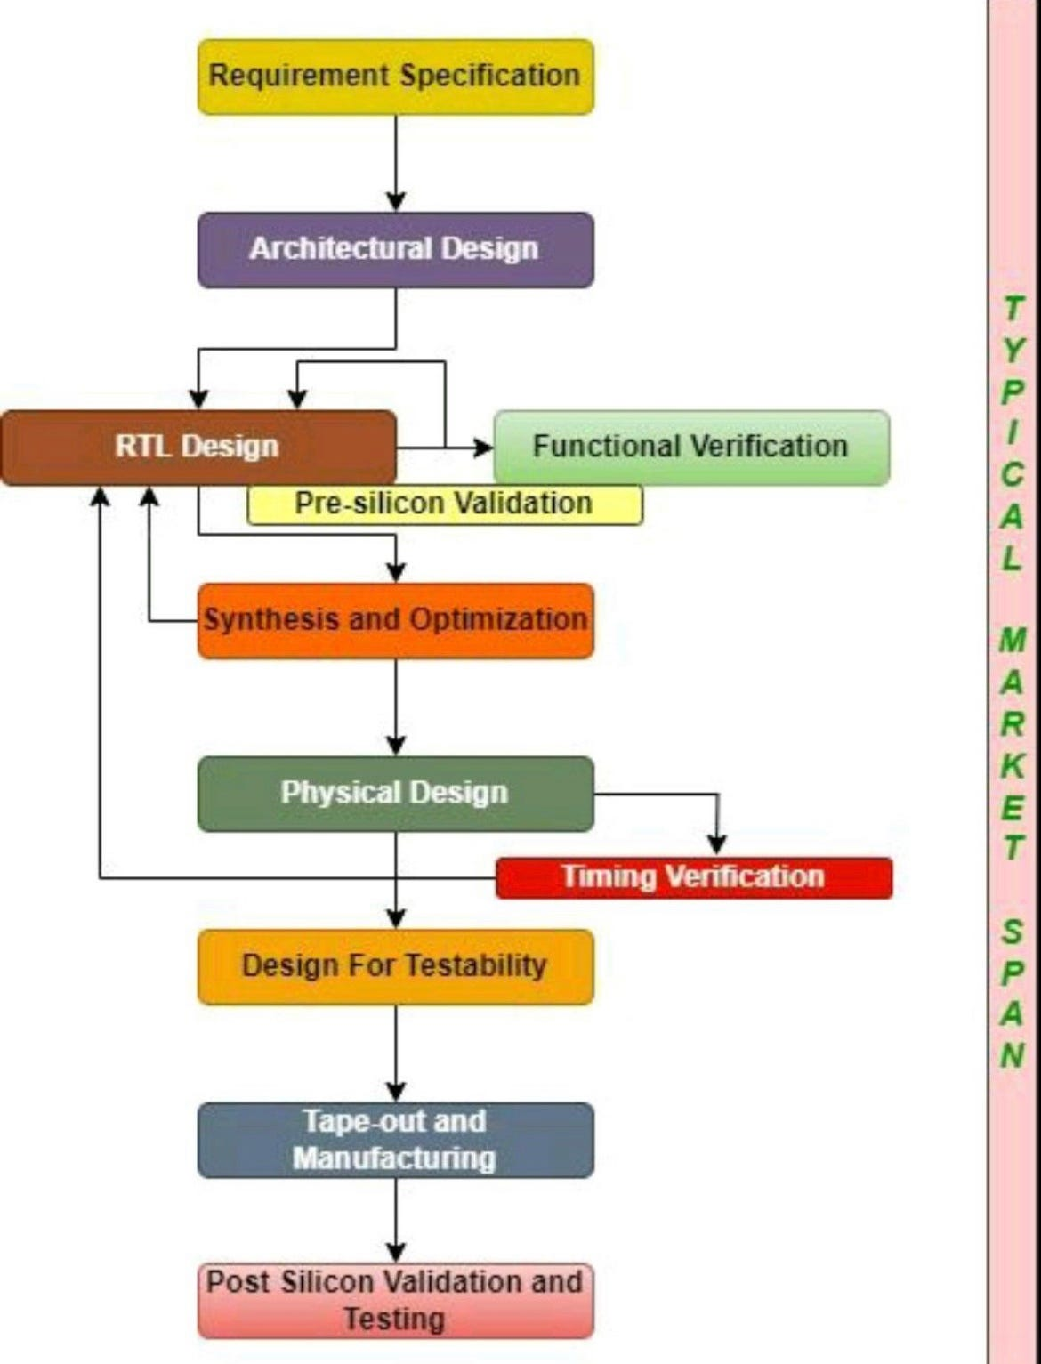

Figure 3.1 : Key Stages VLSI Design

3.1 RTL Design

RTL (Register Transfer Level) design is a method in digital circuit design where logic circuits are described using registers and operations between them. It focuses on data movement and manipulation at the register level, abstracting away from specific hardware details. RTL describes how data is transferred between registers and how it is processed by combinational logic. This abstraction allows designers to specify functionality without concern for the underlying hardware implementation, facilitating easier design verification and synthesis into actual hardware. Thus, RTL serves as a bridge between high-level behavioral descriptions and lower-level gate-level designs in the development of digital systems.

(a) Full Adder :-

A Full Adder is a fundamental digital circuit used in arithmetic operations within processors. It adds three binary inputs: two operands (A and B) and a carry-in (Cin). It produces two outputs: a sum (S) and a carry-out (Cout). The Full Adder uses two XOR gates to compute the sum bit and a combination of AND and OR gates to determine the carry-out. It handles binary addition including carry-over from previous stages, crucial for multi-bit arithmetic and data processing. Full Adders are essential components in CPUs, enabling complex computations and ensuring accurate results in digital systems.
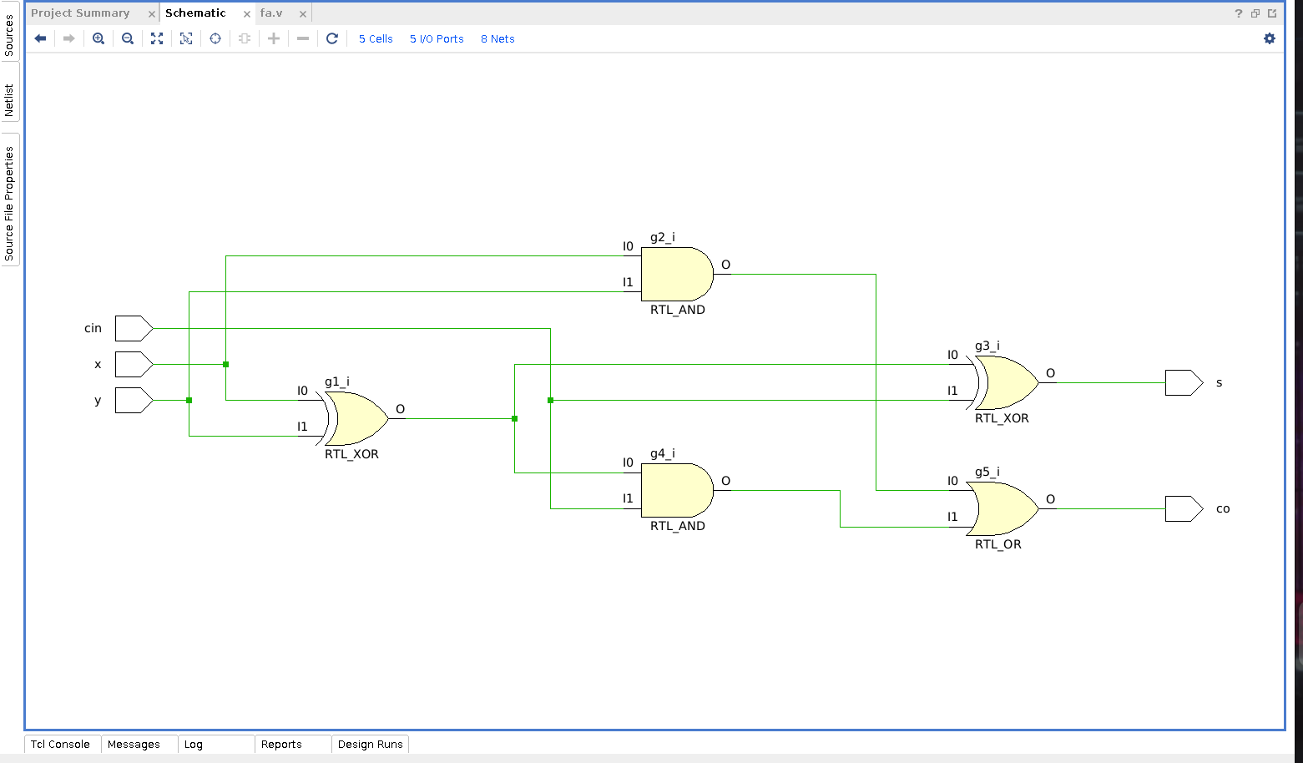
Figure 3.2 : RTL Schematic of Full Adder

(b) Full Subtractor using Full Adder :-

A Full Subtractor utilizes Full Adders to perform binary subtraction. It consists of three inputs: minuend (A), subtrahend (B), and borrow-in (BorrowIn). The circuit computes the difference (Difference) and a borrow-out (BorrowOut). To achieve this, the minuend and subtrahend are complemented, and the borrow-in is inverted. The first Full Adder calculates a preliminary difference and carry-out. The second Full Adder processes the intermediate difference with the inverted borrow-in to adjust the final difference and generate the borrow-out. This construction enables the Full Subtractor to efficiently compute binary subtraction operations while maintaining consistency with the principles of binary arithmetic and logic.

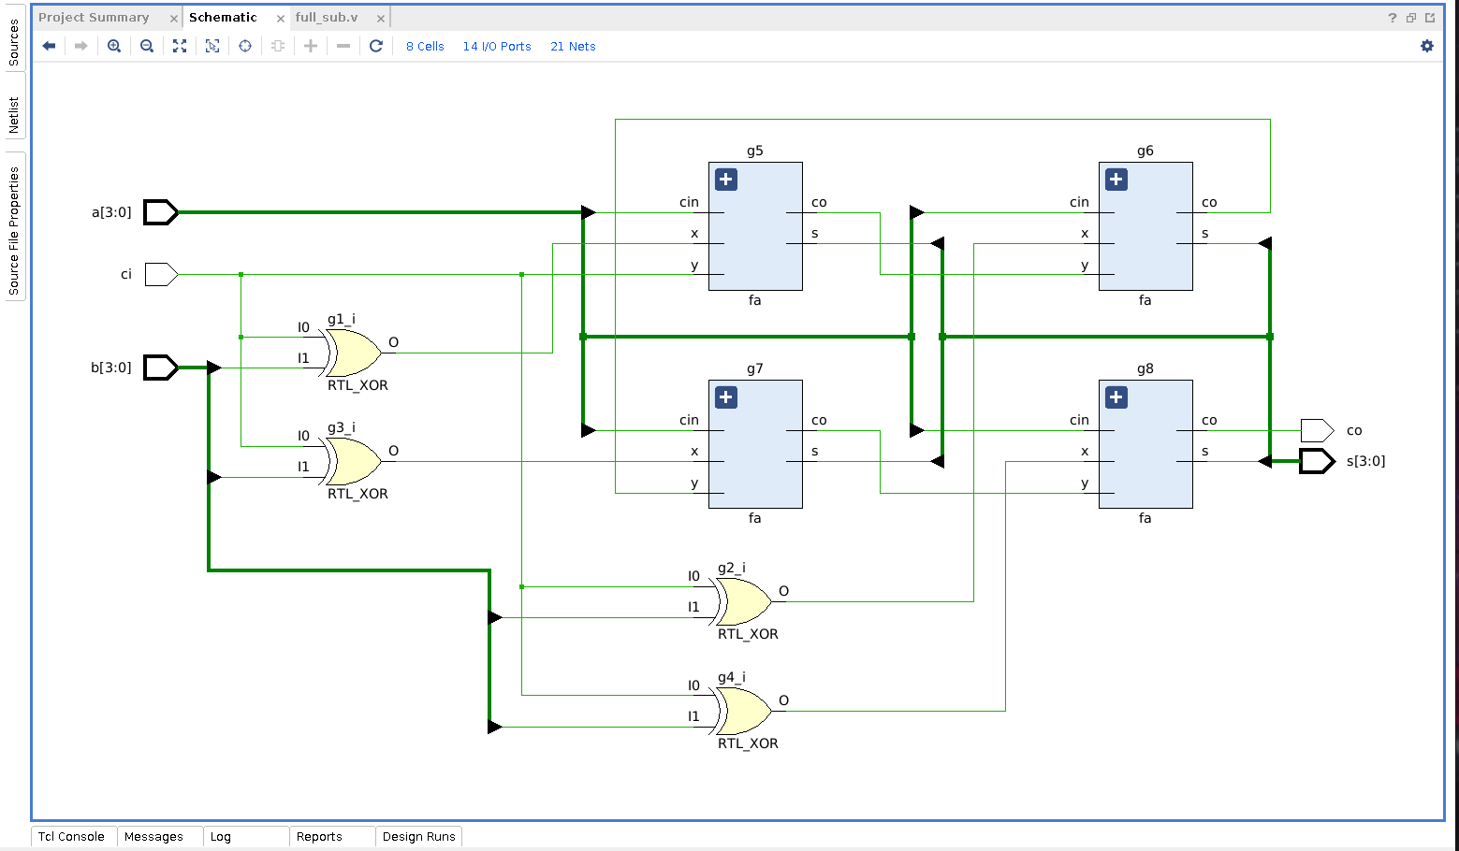
Figure 3.3 : RTL Schematic of Full Subtractor

(c) 8 bit ALU :-

An 8-bit Arithmetic Logic Unit (ALU) is a digital circuit within a processor capable of performing arithmetic (addition, subtraction) and logic operations (AND, OR, XOR) on two 8-bit binary numbers. It includes control inputs to select operations and outputs for the result, along with status flags (carry, zero) indicating conditions like overflow or equality. ALUs are fundamental components of CPUs, executing computations and logical comparisons necessary for data processing in various applications, from basic calculators to complex computer systems handling data-intensive tasks.
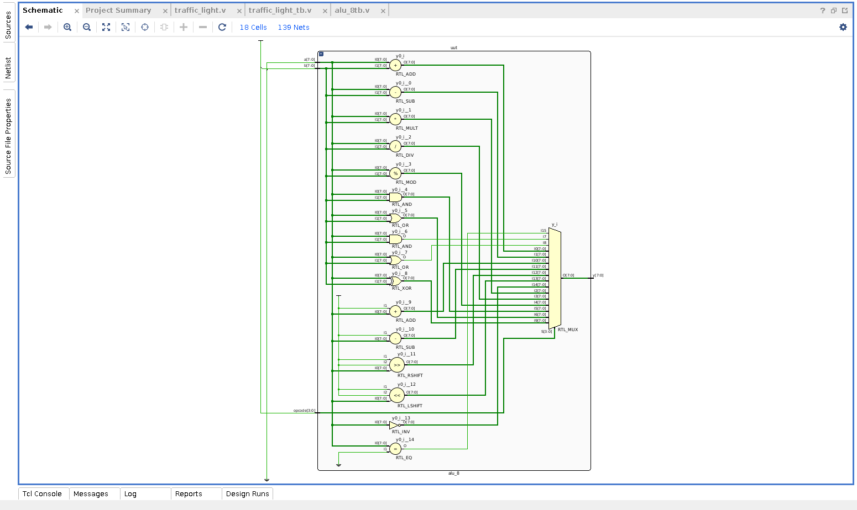
Figure 3.4 : RTL Schematic of 8 bit ALU

(d) 4:1 MUX using 2:1 MUX :-

A 4:1 multiplexer (MUX) is a digital circuit that selects one of four input signals based on a set of control inputs. It has four data inputs (often labeled as A, B, C, and D) and two control inputs (often labeled as S0 and S1) that determine which of the four data inputs is passed through to the output. The output of the 4:1 MUX is a single signal that corresponds to the selected input. This type of multiplexer is commonly used in digital design for selecting between multiple data sources based on specific conditions or control signals.

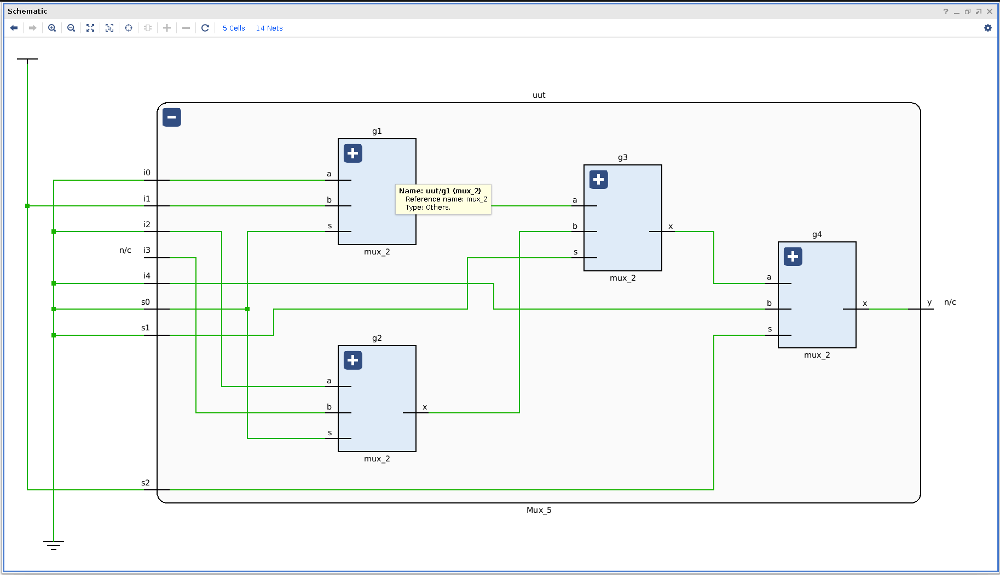

Figure 3.5 : RTL Schematic of 4:1 Multiplexer.

(e) Traffic Light Controller :-
A traffic light controller is an electronic device or system responsible for managing the operation of traffic signals at intersections or pedestrian crossings. It coordinates the timing and sequencing of traffic lights to optimize traffic flow, improve safety, and minimize congestion. Modern controllers use sensors, timers, and algorithms to dynamically adjust signal timings based on real-time traffic conditions, pedestrian crossings, and vehicle queues. They play a crucial role in urban traffic management by ensuring efficient movement of vehicles and pedestrians while adhering to traffic regulations and safety standards.

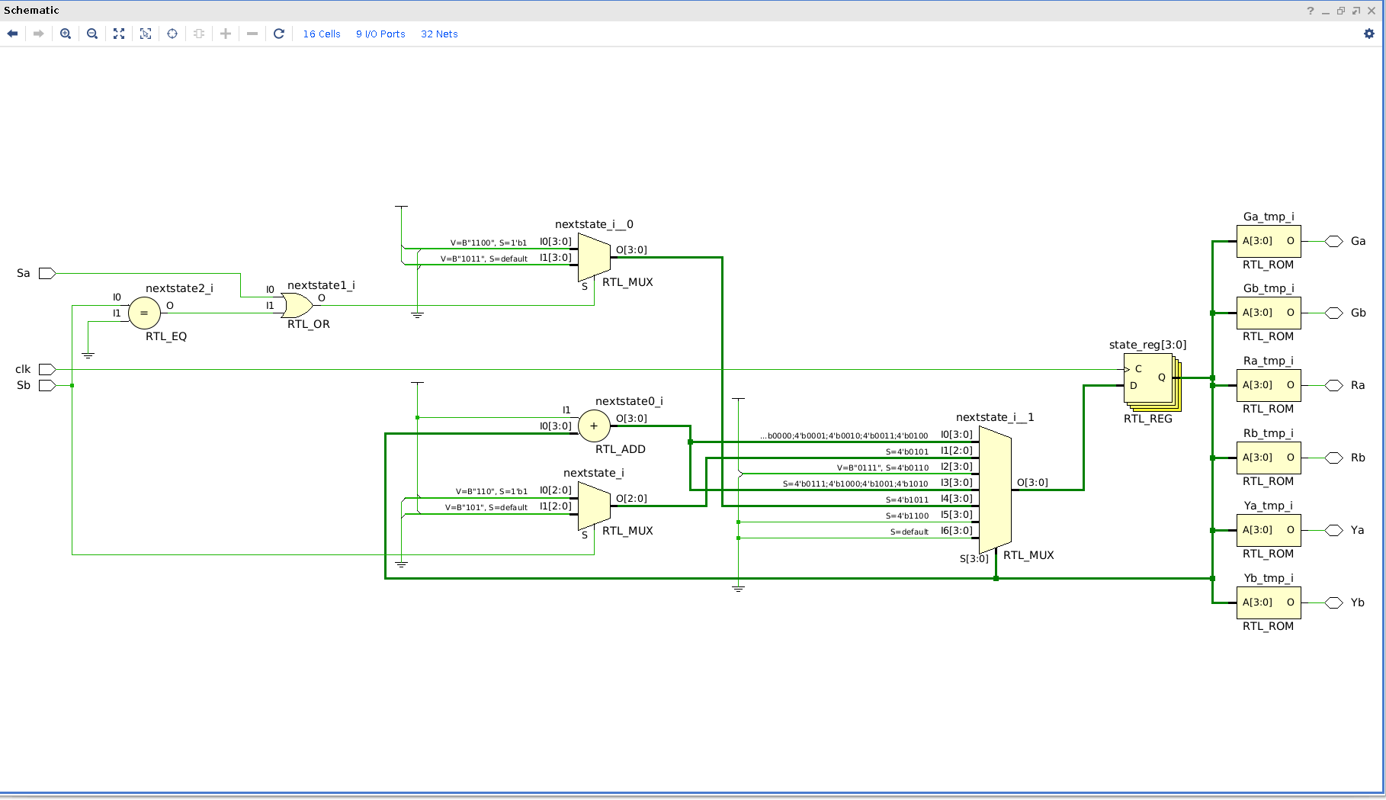
Figure 3.6 : RTL Schematic of Traffic Light Controller.

(f) Complex Multiplier :-

A complex multiplier is a computational unit that calculates the product of two complex numbers, \( (a + bi) \) and \( (c + di) \). It performs this operation by simultaneously multiplying their real and imaginary components: \( ac - bd \) for the real part and \( ad + bc \) for the imaginary part. This calculation is essential in various applications such as digital signal processing (DSP), telecommunications, and radar systems where complex numbers represent signals or data with both magnitude and phase information. Efficient implementation of complex multipliers is crucial for optimizing performance in these advanced signal processing tasks.

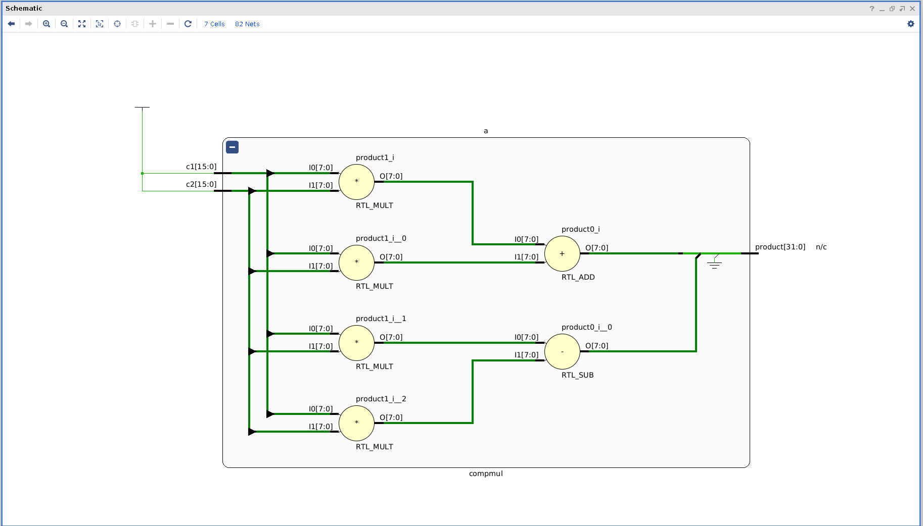
Figure 3.7 : RTL Schematic of Complex multipler .

(g) 4 bit Ripple Carry Adder :-

A 4-bit ripple carry adder is a digital circuit that computes the sum of two 4-bit binary numbers. It consists of four full adder circuits connected in series, where each full adder adds one bit of the operands along with the carry from the previous stage. The carry output from each full adder propagates to the next stage, causing a ripple effect. This sequential addition process starts from the least significant bit (LSB) and propagates to the most significant bit (MSB), hence the term "ripple carry."

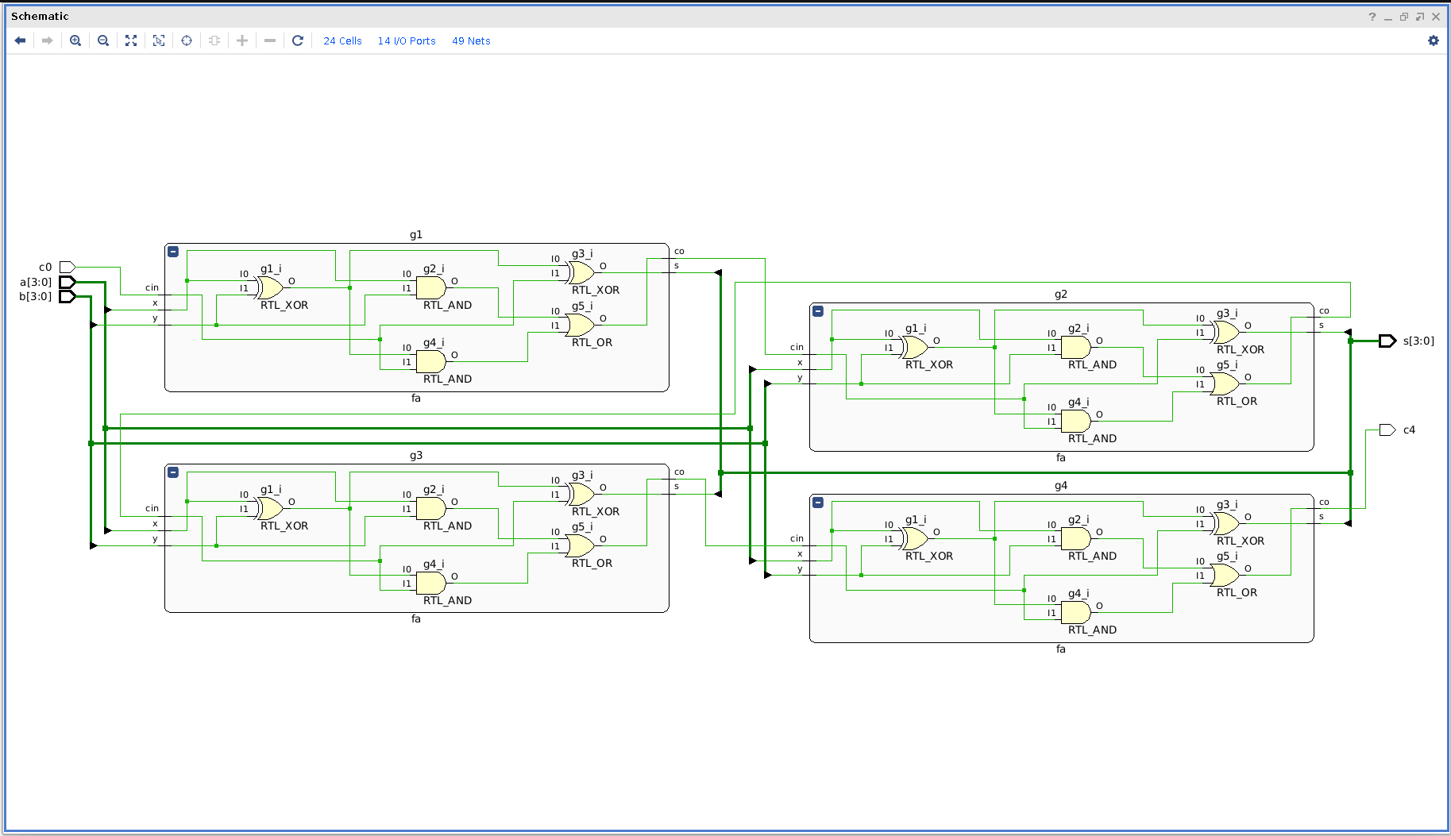
Figure 3.8 : RTL Schematic of 4 bit Ripple Carry Adder.

3.2 Synthesis Using Genus Common UI

RTL synthesis, which stands for Register Transfer Level synthesis, is a crucial step in the process of designing digital integrated circuits (ICs) or systems using hardware description languages (HDLs) such as Verilog or VHDL. It involves translating a high-level RTL description of a digital design into a gate-level representation that can be implemented in hardware.

Key Steps and Concepts Involved in RTL Synthesis :-

1. RTL Description : RTL (Register Transfer Level) is a level of abstraction in digital design where the behavior of a circuit is described in terms of registers (storage elements) and the transfer of data between them. It typically includes operations and interactions between registers, memories, and functional units.

2. Design Constraints : Before synthesis, designers specify various constraints such as timing requirements (clock frequencies, maximum delay), area constraints (chip size limitations), power constraints, and technology-specific rules (like minimum feature sizes) that the synthesis tool must adhere to.

3. Synthesis Process :

Analysis : The synthesis tool first analyzes the RTL description to understand the functionality and structure of the design. This involves identifying registers, combinational logic, control structures (if-else conditions, loops), and their interconnections.

Optimization : Once analyzed, the synthesis tool applies optimizations to improve the design in terms of speed, area, and power consumption. Optimization techniques may include:

Combinational Logic Optimization : Simplifying logic expressions to reduce gate count and delay.

Sequential Optimization : Enhancing register transfer operations to improve timing.

Technology Mapping : Selecting appropriate cells from a technology library that match the required functionality and timing constraints.

Mapping : The synthesis tool maps the RTL constructs to actual gates and flip-flops from the target technology library. This involves choosing appropriate components (logic gates, multiplexers, flip-flops) to implement each part of the design while respecting design constraints.

Verification : Post-synthesis, the tool performs verification checks to ensure that the synthesized design meets the functional requirements specified in the RTL description and adheres to the constraints defined earlier.

4. Output : The output of RTL synthesis is typically a netlist, which is a detailed description of the synthesized design in terms of logic gates and flip-flops. This netlist serves as the input to subsequent stages in the design flow, such as place-and-route and timing analysis, leading eventually to the fabrication of the physical IC.

Importance and Applications :-

Design Productivity : RTL synthesis automates the translation from a high-level design description to a gate-level implementation, saving significant time and effort compared to manual gate-level design.

Performance Optimization : Through advanced algorithms and optimization techniques, RTL synthesis helps improve the performance metrics of digital designs, such as speed, area, and power consumption.

Technology Portability : RTL descriptions are technology-independent, allowing designers to target different semiconductor manufacturing processes or FPGA architectures by changing the synthesis tool's target technology library.

Complexity Management : As designs grow in complexity, RTL synthesis tools handle intricate details efficiently, ensuring that the final implementation meets design specifications and constraints.

In summary, RTL synthesis plays a vital role in modern digital design flows, bridging the gap between high-level behavioral descriptions and the physical implementation of digital circuits, thereby enabling efficient and optimized hardware designs.

The synthesis process contains three Labs : LAB 1 , LAB2 & LAB 3 .

Lab 1: Base Lab for Genus

Basic genus flow involves transforming a high-level Register Transfer Level (RTL) description of a digital design into a gate-level netlist. It includes analysis, optimization, technology mapping, and verification to ensure functional correctness and meet design constraints. The output is a detailed netlist used for subsequent physical design stages in IC fabrication.

In this lab directory the steps of synthesis that are being followed are listed below:

* Starting genus
* Loading Libraries and Design
* Reading SDC Constraints
* Synthesizing the Design

Lab 2: DFT Flow

Design for Testability (DFT) flow ensures semiconductor devices can be tested thoroughly and efficiently during manufacturing. It integrates testability features into the design to detect and diagnose faults. Steps include inserting scan chains for test pattern application, implementing Built-In Self-Test (BIST) structures for on-chip testing, and optimizing for fault coverage. DFT techniques like boundary scan (IEEE 1149.1), ATPG (Automatic Test Pattern Generation), and fault simulation are used. DFT flow aims to achieve high fault coverage while minimizing test application time and hardware overhead, crucial for ensuring reliable operation and reducing field failures in integrated circuits.

In this section, you will set the environment of the synthesis session, load the RTL files,
and elaborate the top-level design.

The steps to complete the DFT Flow are listed below :

* Setting Up the Enviroment
* Loading Libraries
* Reading SDC Constraints
* DFT Setup
* Synthesizing the Design
* DFT Reports

Lab 3: Running Low-Power Synthesis

We run low-power synthesis to insert clock gating for power optimization and to
optimize the leakage and dynamic power.

In this section, we will set the environment of the synthesis session, load the RTL files,
and elaborate the top-level design.

The steps to run low power synthesis are listed below:

* Loading Libraries
* Enabling Clock Gating
* Loading Design
* Reading SDC Constraints
* Setting Power Optimization Attributes
* Running Generic Synthesis
* Running and Reporting Low-Power Synthesis

3.3 Basic Floorplanning in Innovus using Stylus Common UI

What is Innovus Stylus ?

Innovus Stylus is a comprehensive digital design implementation solution developed by Cadence Design Systems. It integrates advanced physical design capabilities, including placement, routing, and timing optimization, into a unified environment. Innovus Stylus leverages machine learning techniques to enhance performance, power efficiency, and area optimization (PPA), enabling faster and more accurate chip design. It supports advanced-node technologies and complex design requirements, facilitating high-quality and efficient design cycles for cutting-edge semiconductor products. The tool's robust features and scalability make it suitable for a wide range of applications, from consumer electronics to automotive and high-performance computing.

Basic Floorplanning :-

Innovus, developed by Cadence Design Systems, offers a comprehensive environment for physical design of integrated circuits, including floorplanning, which is a critical initial step in the physical design flow. Floorplanning in Innovus involves strategically placing the various components of a design, such as standard cells, memories, and I/O pads, on the silicon die to meet design goals such as area, performance, and power.

Basic floorplanning in Innovus typically includes the following steps:

1. Initial Block Placement:- The designer defines the approximate locations and sizes of major functional blocks within the chip. These blocks represent areas allocated for specific functionalities like logic, memory, and I/O.

2. Core and Boundary Creation:- Using Innovus, cores (such as CPU cores or GPU cores) and boundaries are defined. The core area is where the main logic resides, while the boundary defines the area around the core for routing and other purposes.

3. Power and Ground Planning:- Innovus allows designers to plan power grids and ground networks efficiently. This involves placing power pads, generating power straps, and ensuring adequate distribution to minimize voltage drops and ensure reliable operation.

4. Signal Planning:- Signal routing and planning are crucial in floorplanning to ensure that critical signals can be routed optimally without causing timing violations or excessive delays. Innovus provides tools to plan signal routes and establish clear pathways between different functional blocks.

5. Design Rule Checking (DRC):- Throughout the floorplanning process, designers use Innovus to perform Design Rule Checking (DRC). This ensures that all physical design constraints and rules are adhered to, preventing potential manufacturing issues.

6. Optimization and Iteration:- Innovus supports iterative refinement of the floorplan. Designers can optimize placement to achieve better performance metrics such as timing closure, area efficiency, and power consumption. Innovus provides tools for automated placement and optimization based on design constraints and goals.

Overall, basic floorplanning in Innovus is foundational to achieving a well-structured physical design layout that meets performance, area, and power targets while adhering to design rules and constraints essential for successful chip fabrication.

3.3.1 Design Floorplan:-
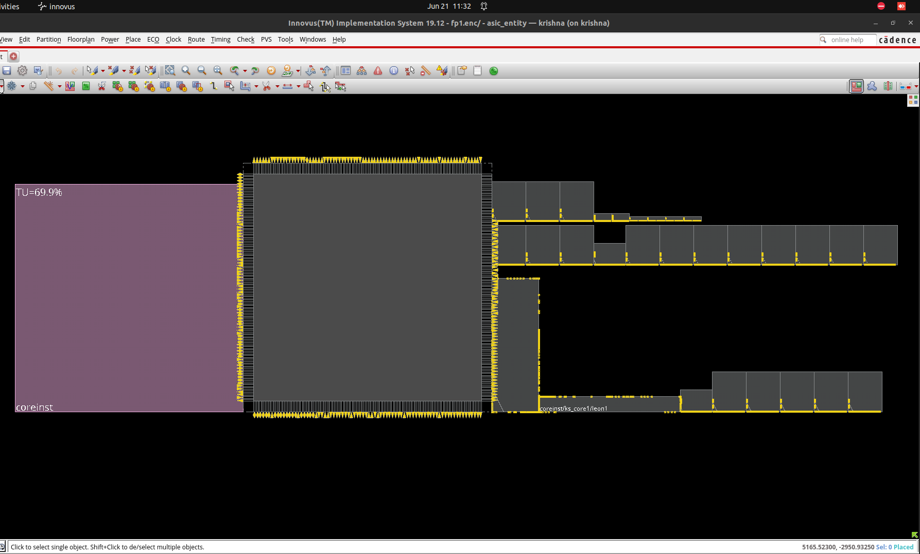
Figure 3.9 : Floorplan View
3.3.2 Connection Between Parent Module and Child Instances:-
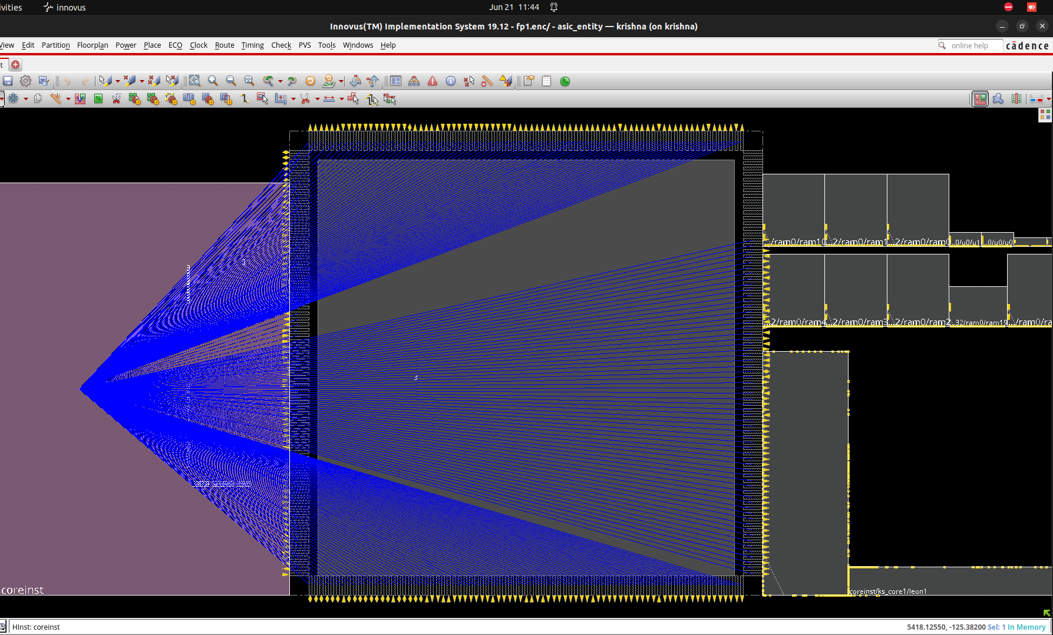

Figure 3.10 : Floorplan View
3.3.3 *ram0/ram0 connection with other Macros:-
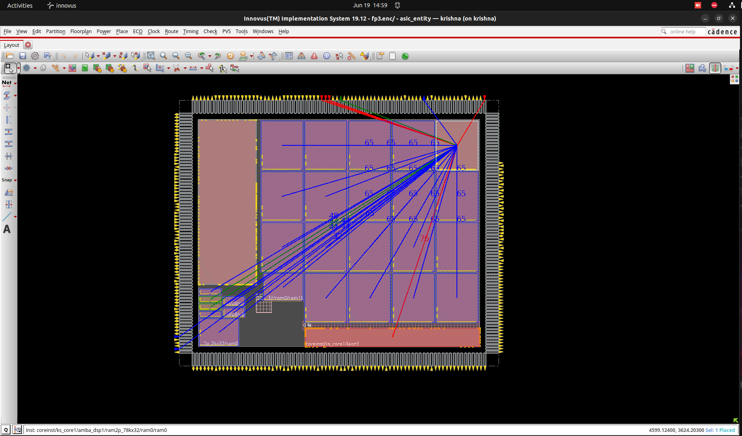

Figure 3.11 : Physical View
3.3.4 Complete Floorplan :-
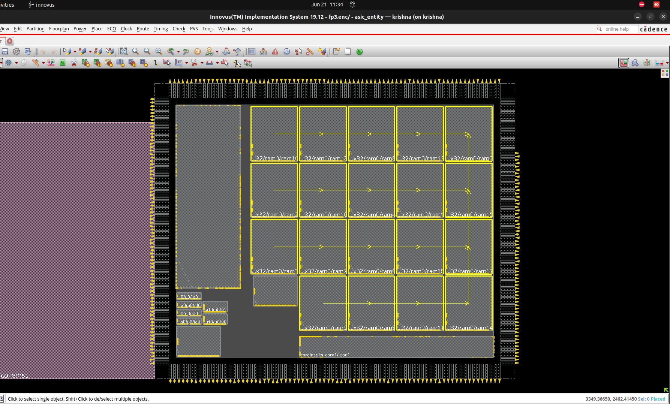
Figure 3.12 : Floorplan View
3.3.5 Finished Floorplan :-
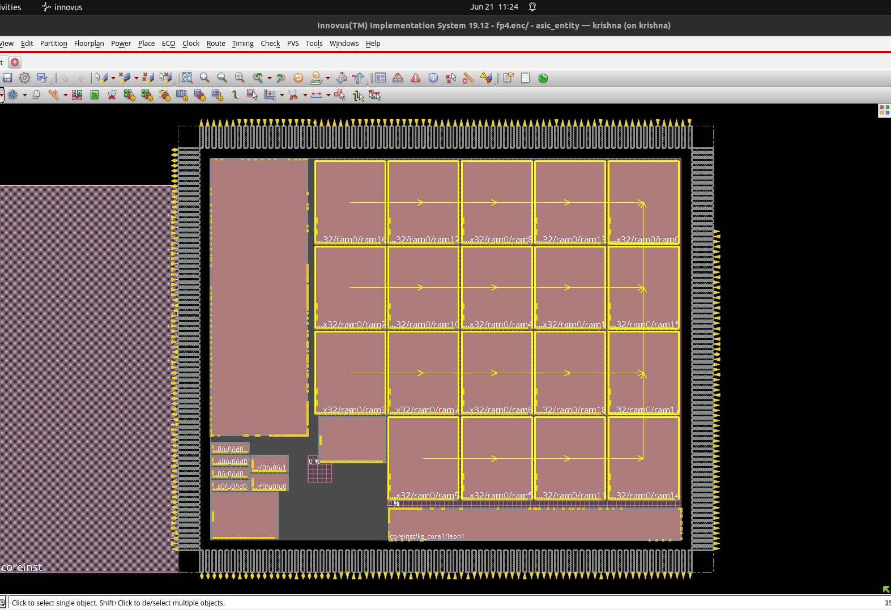

Figure 3.13 Floorplan View
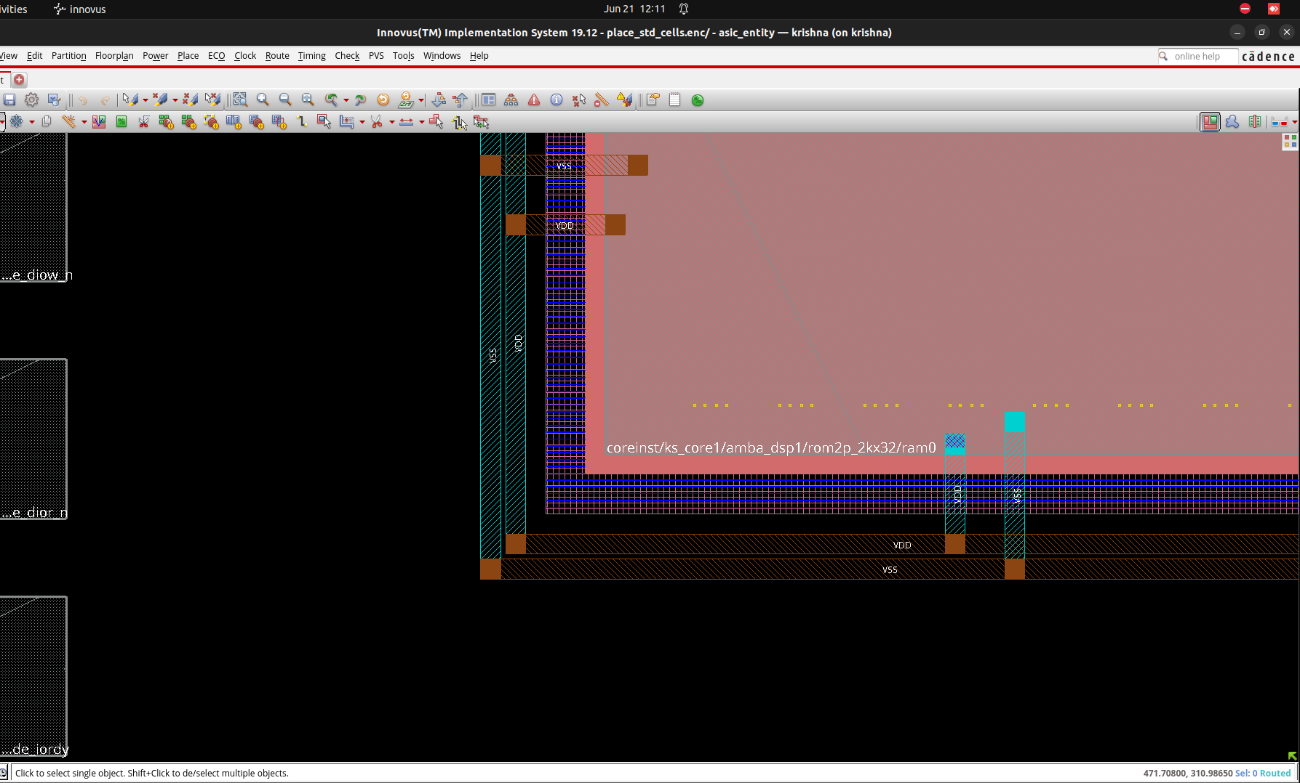
3.3.6 Power Rings:-

Figure 3.14 : Floorplan View
3.3.7 coreinst/ks_core1/periph_PH block with Power Rings :-
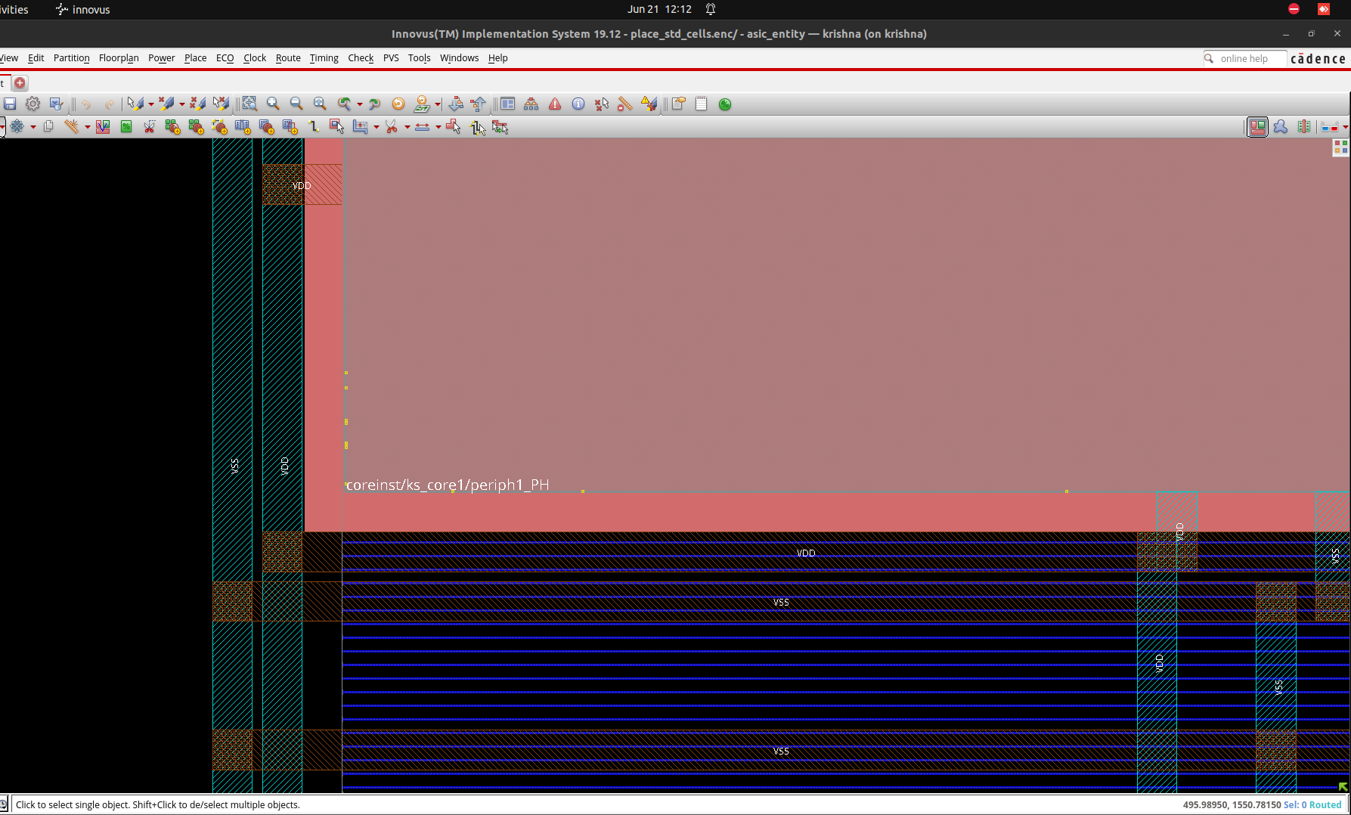

Figure 3.15 : Floorplan View
3.3.8 Horizontal Power and Ground Stripes :-
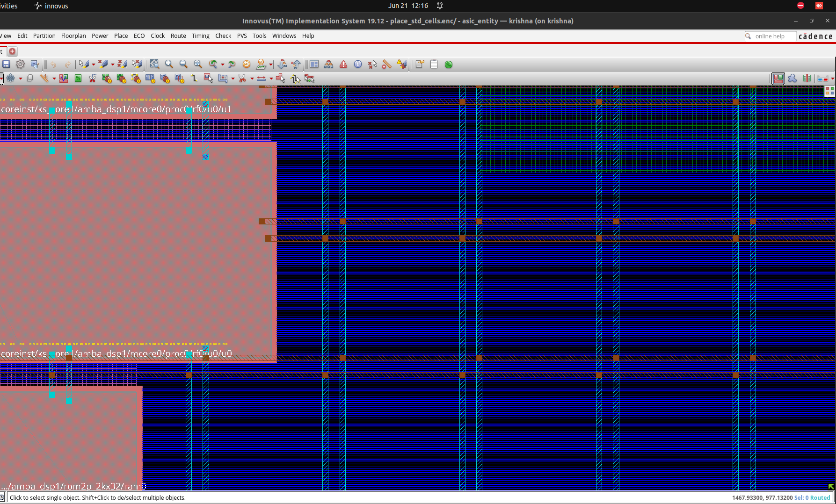
Figure 3.16 : Floorplan View
3.3.9 Design after creating Power Rails :-
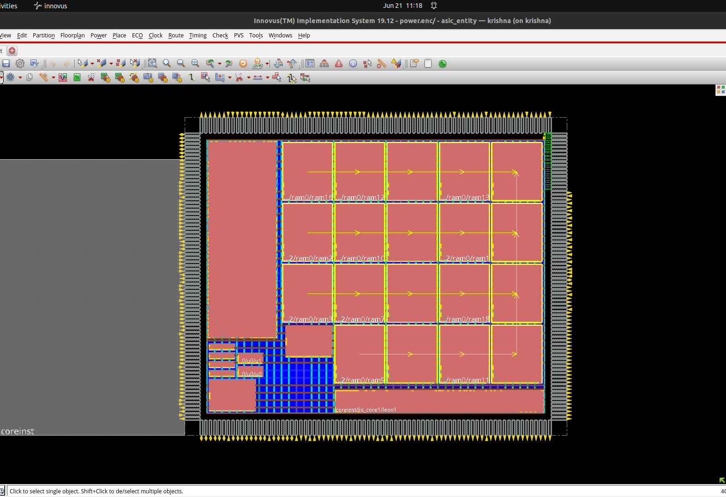
Figure 3.17 : Floorplan View

3.4 Block Implementation Flow using Stylus Interface of Innovus

What is PnR (Placement and Routing) ?

Placement and routing are crucial stages in the physical design process of digital integrated circuits (ICs). They involve determining the physical locations of the components and the connections between them on the silicon chip. Here's a more detailed explanation:

Placement

Placement is the process of positioning the standard cells, macro cells, and other components on the chip. The goal is to place these elements in a way that optimizes performance, minimizes area, reduces power consumption, and ensures the design meets timing requirements.

Steps involved in placement include:

1. Initial Placement :- Placing cells based on their connectivity and initial estimates to form a rough layout.
2. Global Placement :- Refining the initial placement to optimize the overall chip layout, focusing on minimizing wirelength and congestion.
3. Detailed Placement :- Fine-tuning the placement to fix any overlaps and further optimize the design for timing, power, and area.
4. Legalization :- Adjusting the placement to ensure all cells are placed within the defined rows and columns, adhering to design rules and constraints.

Routing

Routing is the process of creating the actual metal interconnections (wires) between the placed components. This involves determining the paths for all the electrical connections while adhering to design rules and optimizing for performance metrics such as timing, signal integrity, and power.

Steps involved in routing include:

1. Global Routing :- Creating a high-level routing plan that outlines the general paths for the connections, dividing the chip into regions and channels.
2. Detailed Routing :- Implementing the actual routes for each connection at the metal layer level, ensuring that all design rules are followed and minimizing issues like crosstalk and signal delay.
3. Routing Optimization :- Adjusting the routing paths to resolve any violations, reduce congestion, and improve timing and signal integrity.
4. Design Rule Check (DRC) :- Ensuring that all routed connections comply with the manufacturing rules to prevent fabrication issues.

Importance of Placement and Routing

Performance :- Proper placement and routing ensure that the design meets timing constraints, reducing delays and improving overall performance.
Area :- Efficient placement minimizes the silicon area required, which can lower costs.
Power Consumption :- Optimal placement and routing can reduce power consumption by minimizing wirelength and capacitance.
Manufacturability :- Ensuring that the design adheres to design rules and constraints is crucial for successful fabrication.

In summary, placement and routing are essential for transforming a logical design into a physical layout that can be manufactured efficiently and meets the required performance, power, and area specifications.

What is CTS (Clock Tree Synthesis) ?

Clock Tree Synthesis (CTS) is a critical process in the physical design of digital integrated circuits, aimed at distributing the clock signal evenly across the entire chip. The clock signal is essential for synchronizing the sequential elements (like flip-flops) in a digital circuit, and CTS ensures that this signal reaches all parts of the chip with minimal skew and delay. Here’s a more detailed explanation of CTS:

Objectives of Clock Tree Synthesis
- Minimize Clock Skew: Clock skew is the difference in arrival times of the clock signal at different flip-flops. Minimizing skew ensures synchronous operation and timing accuracy.
- Minimize Clock Latency: Clock latency is the delay from the clock source to the flip-flops. Reducing latency improves the overall speed of the circuit.
- Balanced Load Distribution: Ensuring that the clock signal is distributed with balanced loading to avoid hotspots and reduce power consumption.
- Signal Integrity: Maintaining the integrity of the clock signal by preventing noise and ensuring a clean, sharp signal with minimal jitter.

Steps in Clock Tree Synthesis
- Clock Tree Planning:
  - Define the clock sources and endpoints (flip-flops and other sequential elements).
  - Plan the hierarchy and structure of the clock tree based on the design’s requirements.
- Insertion of Clock Buffers and Inverters:
  - Place clock buffers and inverters to drive the clock signal across the chip, ensuring sufficient drive strength and reducing signal degradation.
  - Balance the load by inserting these elements at strategic points.
- Clock Tree Construction:
  - Create a hierarchical clock tree structure, branching out from the clock source to all endpoints.
  - Use algorithms to optimize the tree structure for minimal skew and latency.
- Skew and Latency Optimization:
  - Adjust the placement of clock buffers and inverters to fine-tune the clock arrival times.
  - Perform iterations to minimize skew and ensure balanced latency across the clock network.
- Clock Gating Implementation:
  - Introduce clock gating elements to reduce power consumption by disabling the clock signal to certain parts of the chip when not in use.
- Clock Tree Verification:
  - Verify the constructed clock tree using tools to ensure that the skew, latency, and other parameters meet the design specifications.
  - Perform static timing analysis (STA) to check for timing violations and fix any issues.
- Post-CTS Optimization:
  - Perform additional optimization to address any issues identified during verification, such as adjusting buffer placements or rerouting segments of the clock tree.

Importance of Clock Tree Synthesis
- Timing Accuracy: Ensures that the clock signal is synchronized across the entire chip, which is crucial for the correct operation of the circuit.
- Performance: A well-synthesized clock tree helps achieve high performance by minimizing clock skew and latency, allowing faster clock speeds.
- Power Efficiency: Proper clock gating and balanced load distribution reduce power consumption, which is essential for battery-operated and energy-efficient devices.
- Signal Integrity: Maintains a clean and stable clock signal, reducing the risk of timing errors and improving overall reliability.
In summary, Clock Tree Synthesis is essential for ensuring that the clock signal is distributed efficiently and accurately across a digital circuit, which is vital for the performance, power efficiency, and reliability of the final chip.
Imported Design :
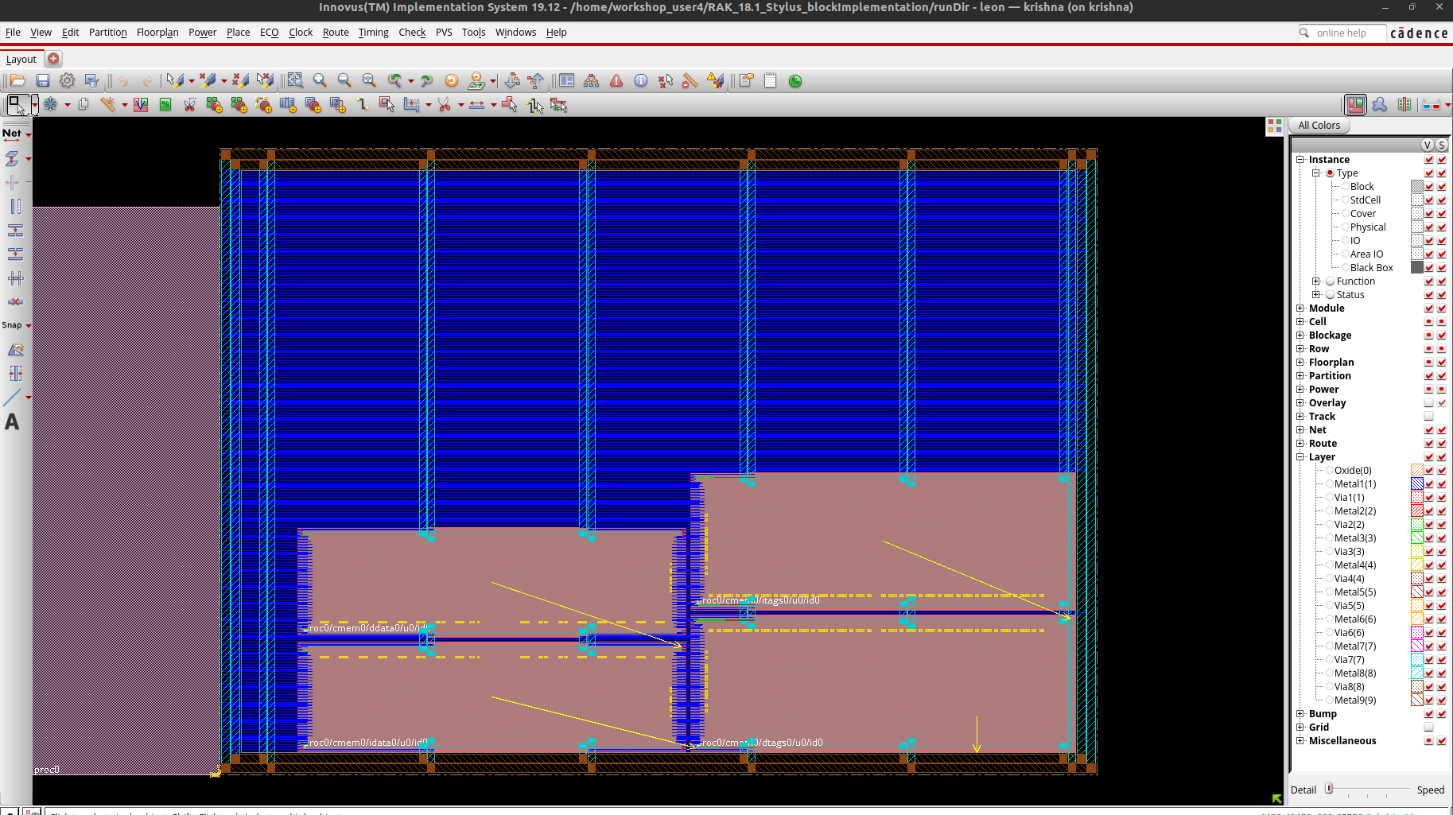
Figure 3.18 : Floorplan View
Placed Design :
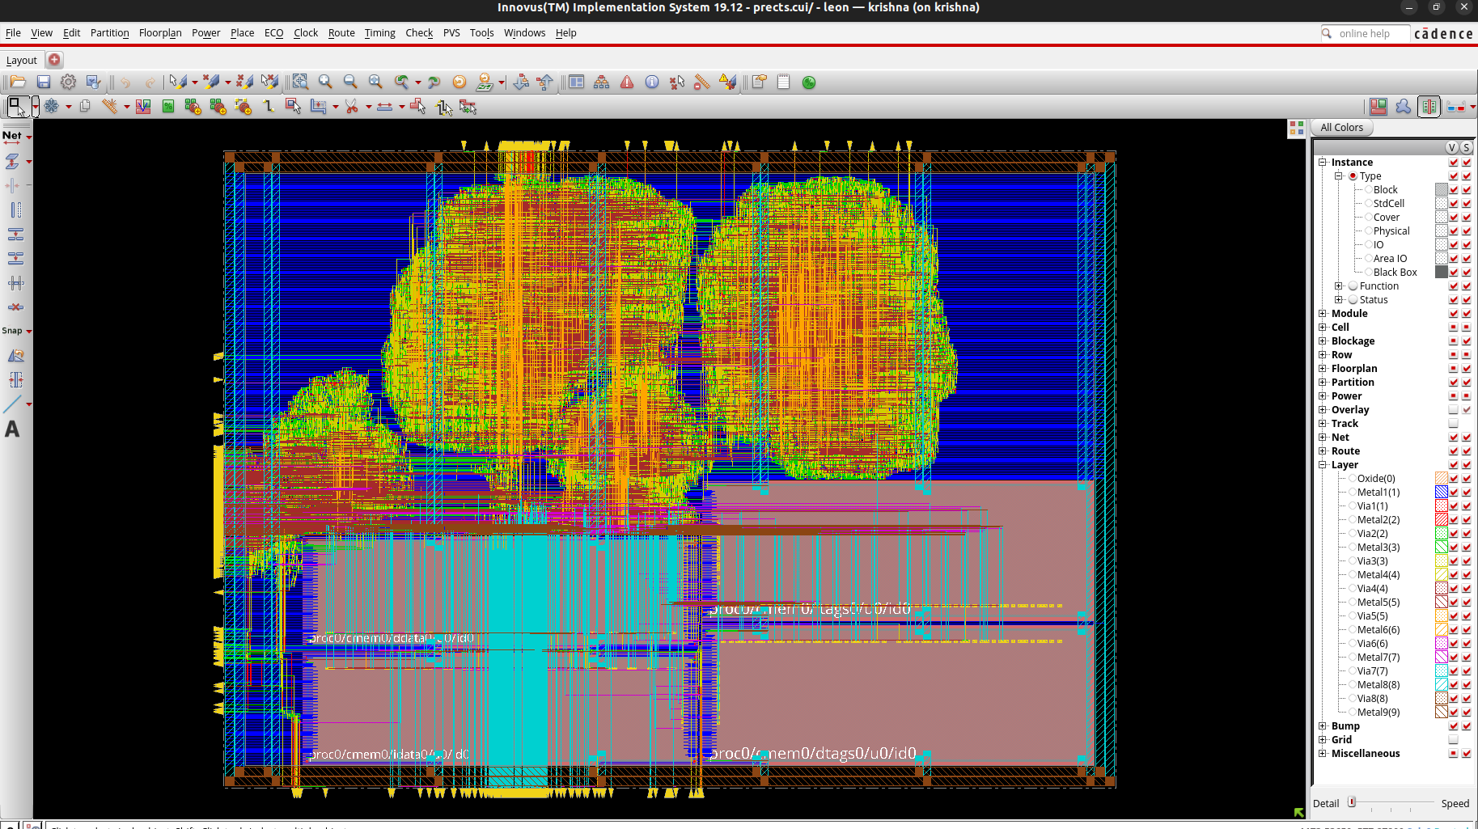

Figure 3.19 : Physical View
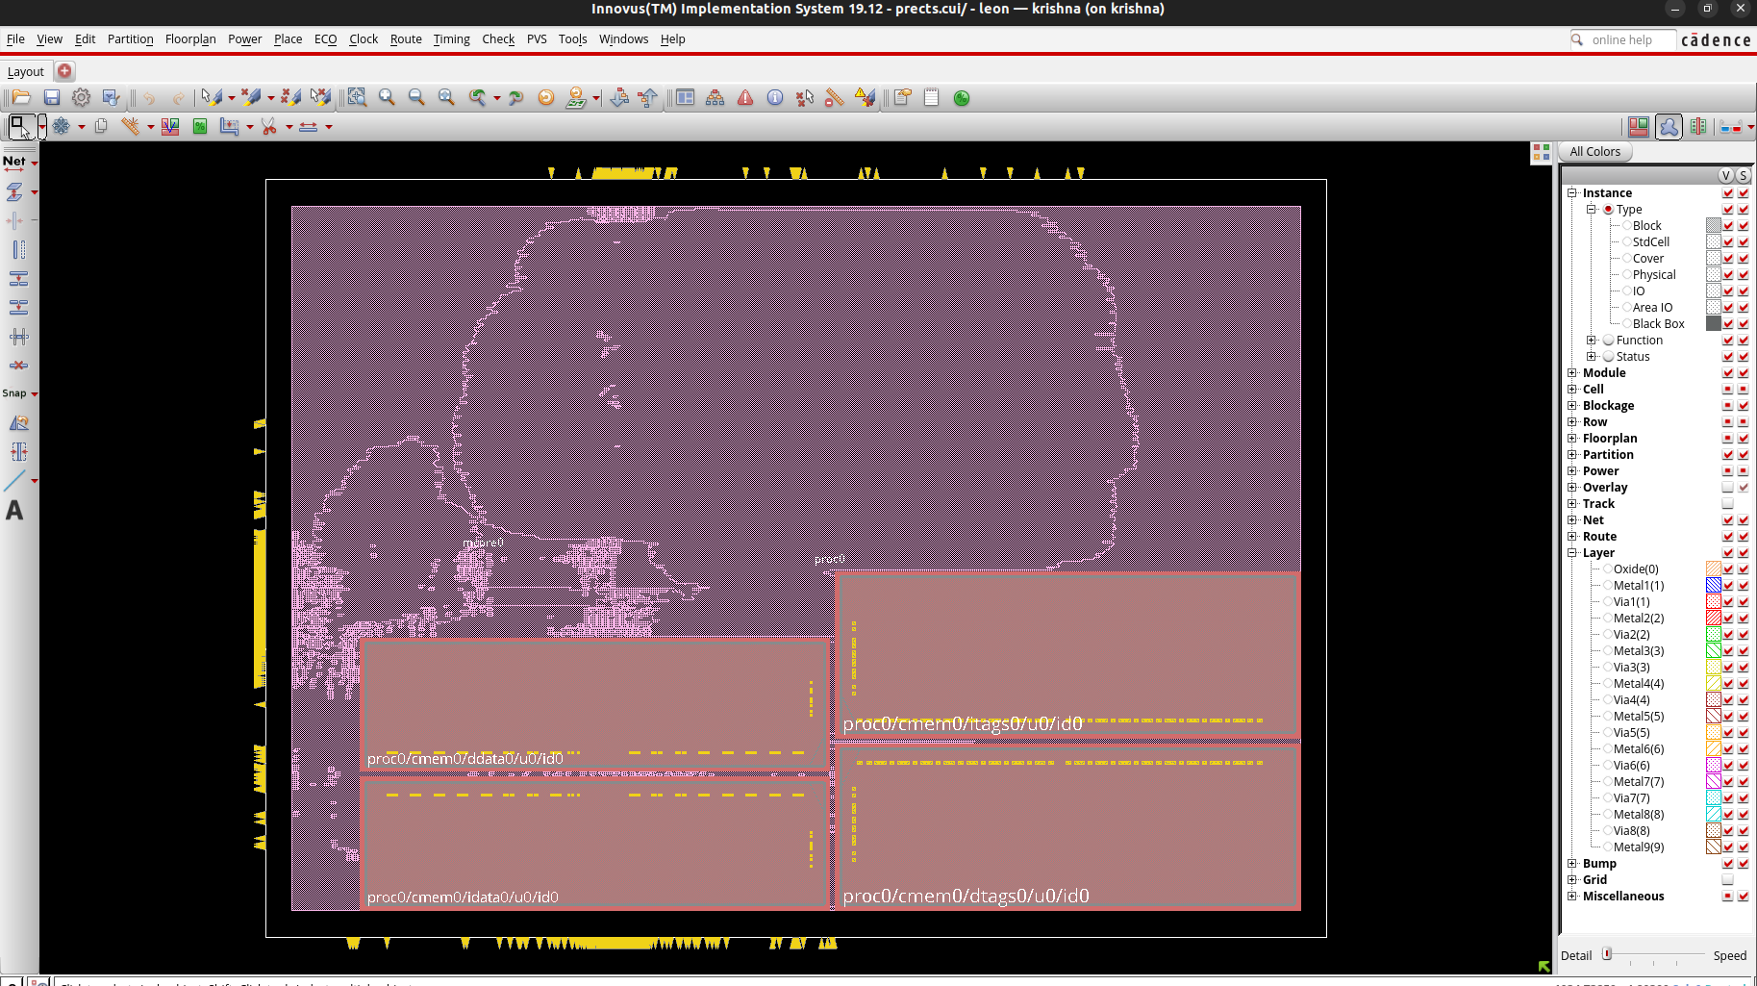
Figure 3.20 : Amoeba View

2-D View of Early Global Congestion :
Early global congestion refers to the initial evaluation of potential routing congestion issues during the early stages of physical design. It helps identify and mitigate areas where routing resources might be insufficient, ensuring smoother and more efficient placement and routing processes, ultimately leading to a better-performing and manufacturable chip design.
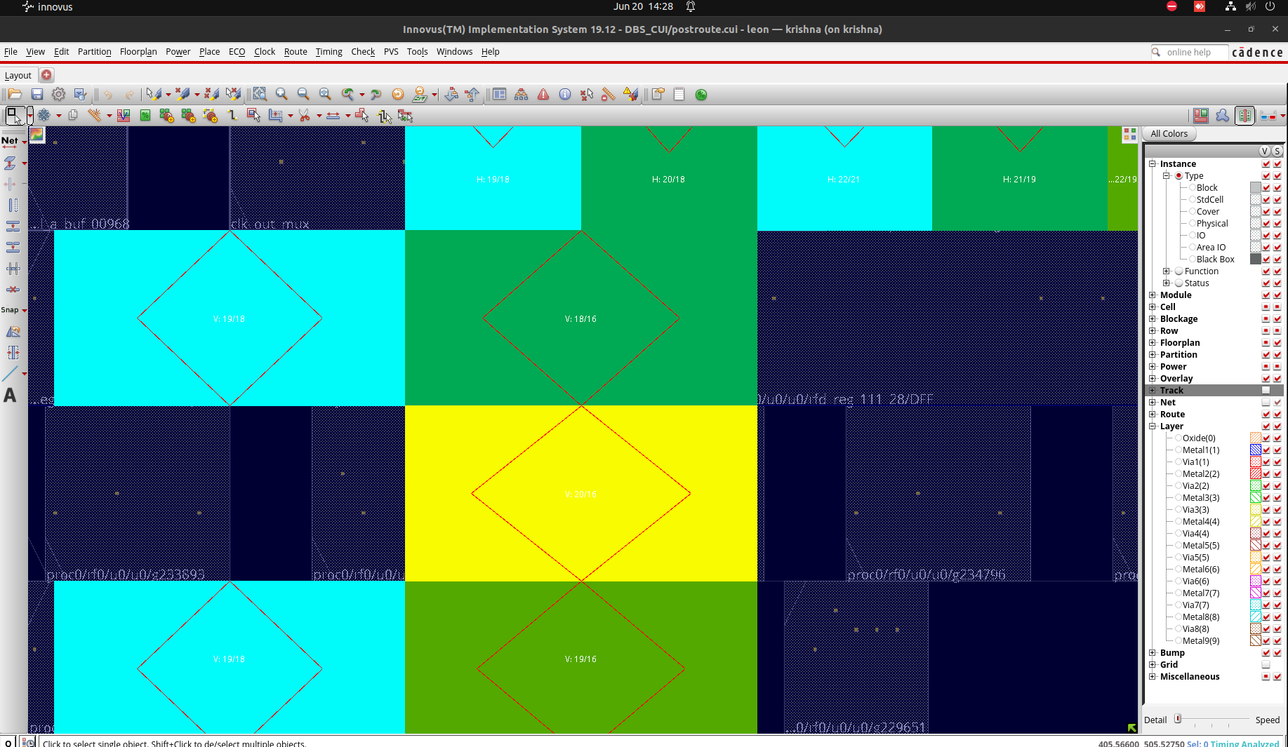
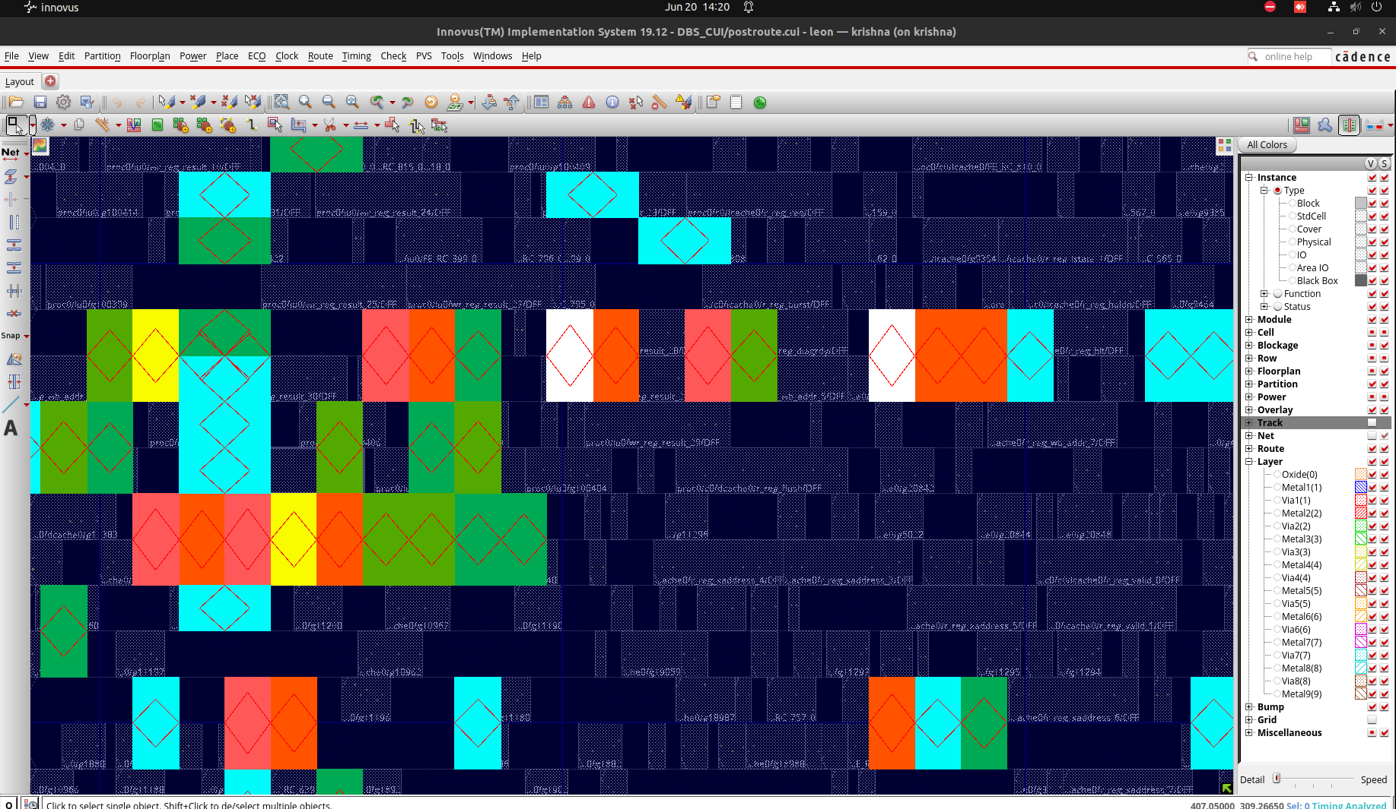
Figure 3.21 : Physical View

Figure 3.22 : Physical View

Timing Debug Display :

Timing debug involves identifying and resolving timing violations in a digital circuit. This process ensures that signal delays meet design constraints across various paths, including setup, hold, and clock-to-output timing. Effective timing debug enhances the circuit's reliability, performance, and overall functionality by ensuring accurate timing alignment.

A Timing Debug form displays path histogram and a Timing Browser displays in the
Innovus main window.
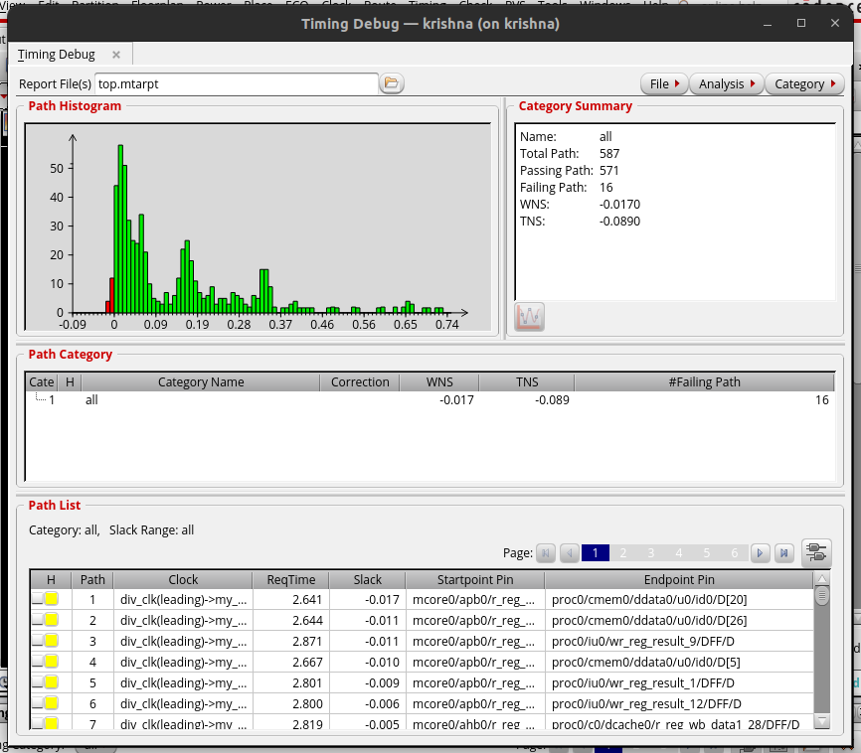
Figure 3.23 : Physical View
CCOpt Clock Tree Debugger (CTD) :

CCOpt Clock Tree Debugger is a tool designed to facilitate the analysis and optimization of clock trees in digital integrated circuits. It is part of the Cadence Tempus Timing Signoff Solution and serves the following primary functions:

Key Features and Functions
- Detailed Visualization:
  - Provides a graphical interface to visualize the clock tree structure, showing the paths from the clock source to endpoints.
  - Highlights areas with potential issues such as excessive skew or high latency.
- Skew and Latency Analysis:
  - Allows detailed examination of clock skew and latency across the clock tree.
  - Identifies paths with timing violations and provides insights into their causes.
- Debugging Tools:
  - Offers tools to analyze the impact of different design parameters on clock performance.
  - Helps debug and resolve issues by suggesting modifications to the clock tree.
- Optimization Guidance:
  - Provides recommendations for optimizing the clock tree to reduce skew and latency.
  - Suggests adjustments like buffer insertion, resizing, or repositioning to improve clock distribution.
- Integration with Timing Analysis:
  - Works in conjunction with static timing analysis tools to verify the clock tree's impact on overall timing performance.
  - Ensures that the optimized clock tree meets all timing constraints.

Importance in Design Flow
- Accuracy: Ensures that the clock tree meets stringent timing requirements, reducing the risk of timing-related failures.
- Efficiency: Helps designers quickly identify and fix clock distribution issues, saving time in the design cycle.
- Performance: Optimizes the clock tree to enhance the overall performance of the chip by minimizing clock skew and latency.
- Reliability: Ensures a robust clock distribution network, essential for the reliable operation of high-speed digital circuits.
In summary, CCOpt Clock Tree Debugger is an essential tool for fine-tuning and verifying the clock distribution network in digital ICs, ensuring optimal performance and reliability.

Clock Tree debugger :

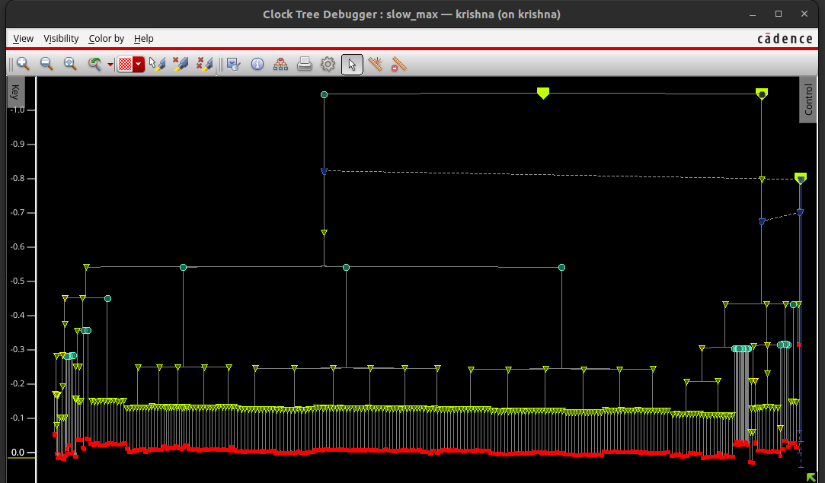
Figure 3.24

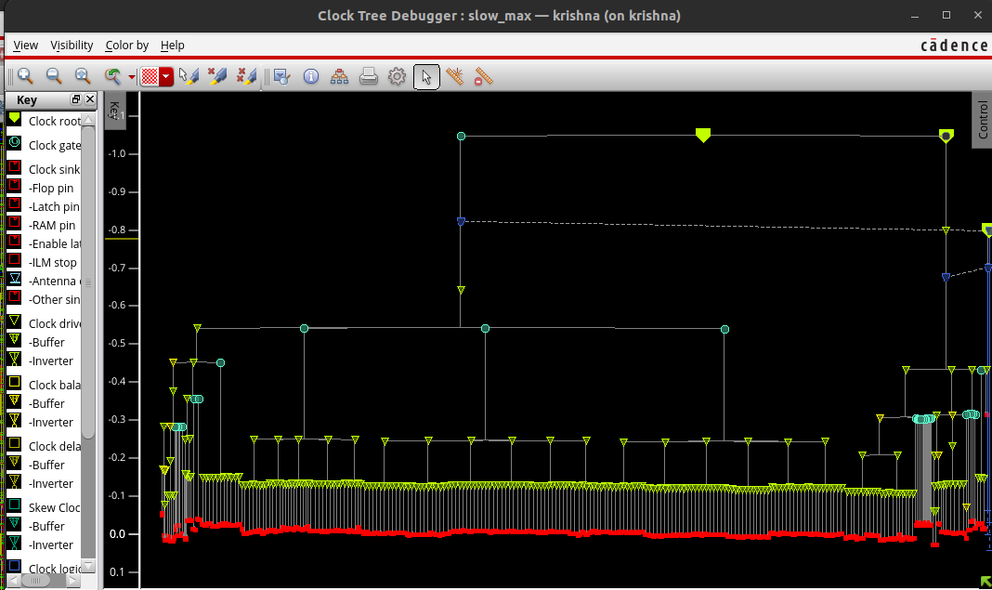
Figure 3.25
CTD colour by transition time :
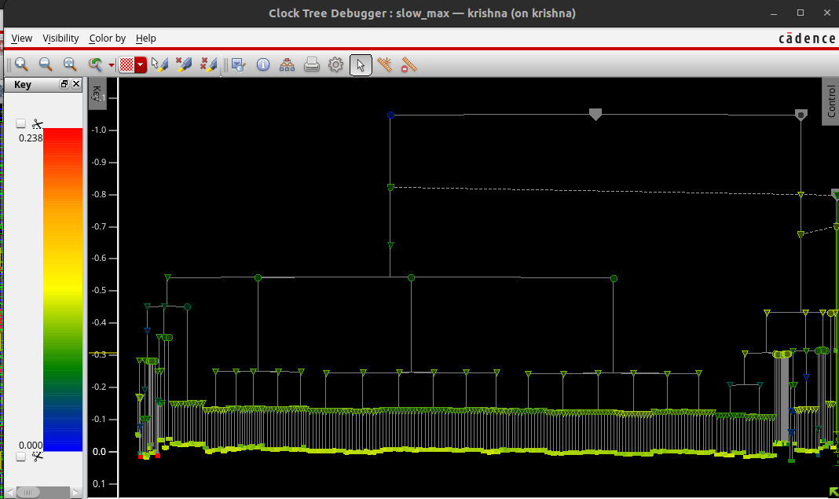
Figure 3.26
Instance or Net view in Debugger :
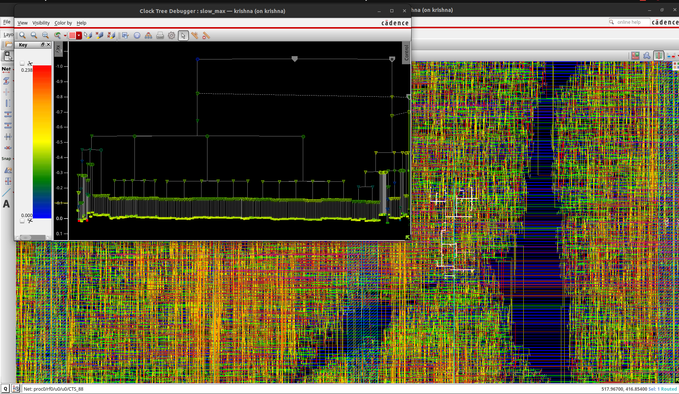
Figure 3.27
Clock Tree Display :
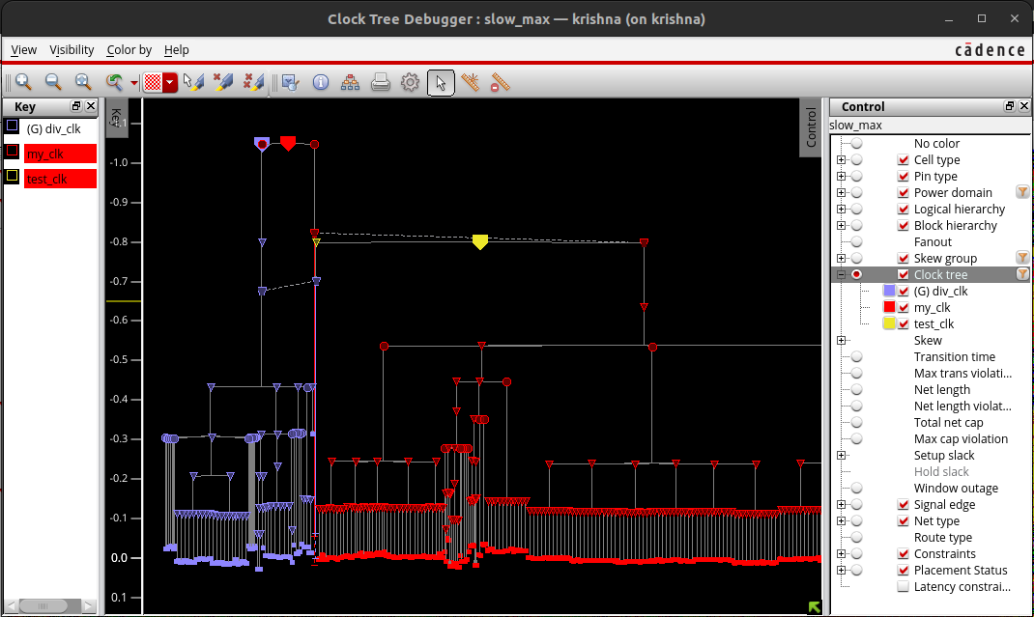
Figure 3.28
Clock Tree Display (No Colour) :
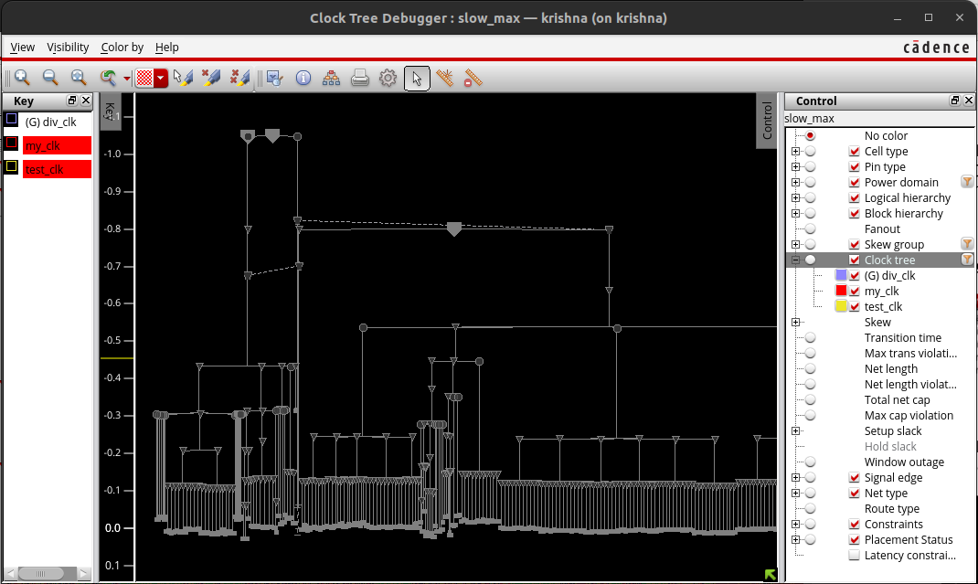
Figure 3.29
Clock Tree Display Max Path Highlight :
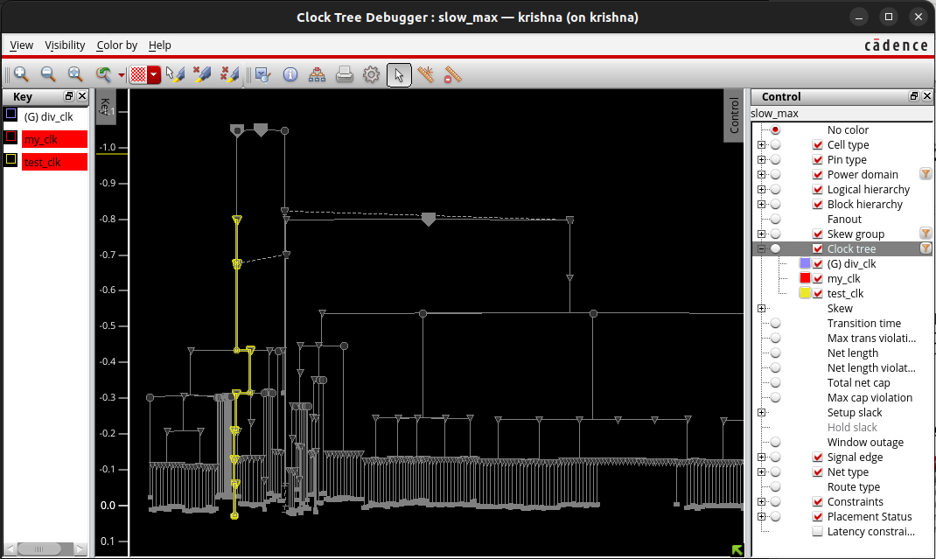
Figure 3.30

Clock Tree Display Min Path Highlight :
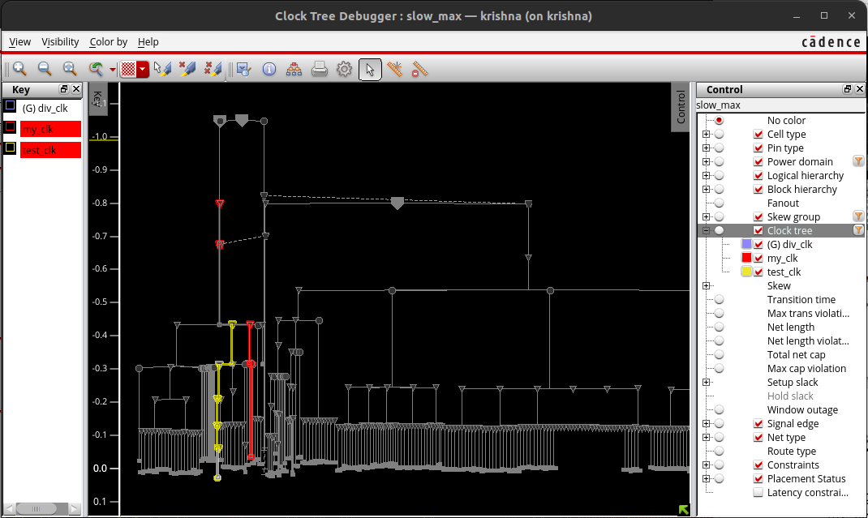
Figure 3.31

Post Route Timing and SI Optimization :

Post-Route Timing
Post-route timing refers to the analysis and verification of timing after the routing stage in the physical design flow of an integrated circuit (IC). At this stage, the design has undergone placement and routing, meaning all the physical connections between components are established. Key aspects of post-route timing include:
- Static Timing Analysis (STA):
  - Performs a comprehensive timing check to ensure all timing constraints (setup and hold times) are met.
  - Evaluates the worst-case delays across different paths in the design.
- Critical Path Analysis:
  - Identifies the most critical paths that determine the maximum operating frequency of the chip.
  - Ensures these paths meet the required timing margins.
- Clock Timing Verification:
  - Ensures that the clock tree distribution meets the intended design specifications for skew and latency.
  - Verifies the timing of clock gating elements and their impact on the overall timing.
- Timing Violations Resolution:
  - Identifies and resolves setup and hold violations by adjusting placement, routing, or buffer insertion.
  - May involve re-optimization steps to meet timing requirements.

Signal Integrity (SI) Congestion
SI congestion refers to issues related to signal integrity caused by routing congestion in an IC design. Signal integrity problems arise due to unwanted interactions between signal wires, such as crosstalk, noise, and excessive delay. SI congestion specifically involves:
- Crosstalk Analysis:
  - Evaluates the impact of signal interference between adjacent wires, which can cause timing violations and functional errors.
  - Identifies regions where signal lines are too close, leading to excessive crosstalk.
- Noise Analysis:
  - Analyzes the noise margins to ensure that signals maintain their integrity without being corrupted by electrical noise.
  - Ensures that noise levels are within acceptable limits to prevent functional failures.
- Electromigration and IR Drop:
  - Assesses the impact of high current densities on metal interconnects, which can lead to reliability issues like electromigration.
  - Evaluates IR drop, which is the voltage drop across power distribution networks, ensuring sufficient power delivery to all components.
- Routing Congestion:
  - Identifies regions with high routing density that may lead to SI issues.
  - Provides insights into possible re-routing or layer usage adjustments to alleviate congestion.

Importance in Design Flow
- Post-Route Timing:
  - Ensures the design meets all timing requirements, crucial for the reliable operation of the chip at the intended clock speeds.
  - Helps in achieving the best possible performance by fine-tuning the critical paths and clock distribution network.
- SI Congestion:
  - Ensures signal integrity, preventing functional errors and improving the overall reliability of the chip.
  - Addresses potential manufacturing and operational issues early in the design flow, reducing the risk of costly re-spins.
In summary, post-route timing and SI congestion are critical steps in the physical design flow that ensure the IC meets performance, reliability, and manufacturability requirements.

3-D Layout of Design :
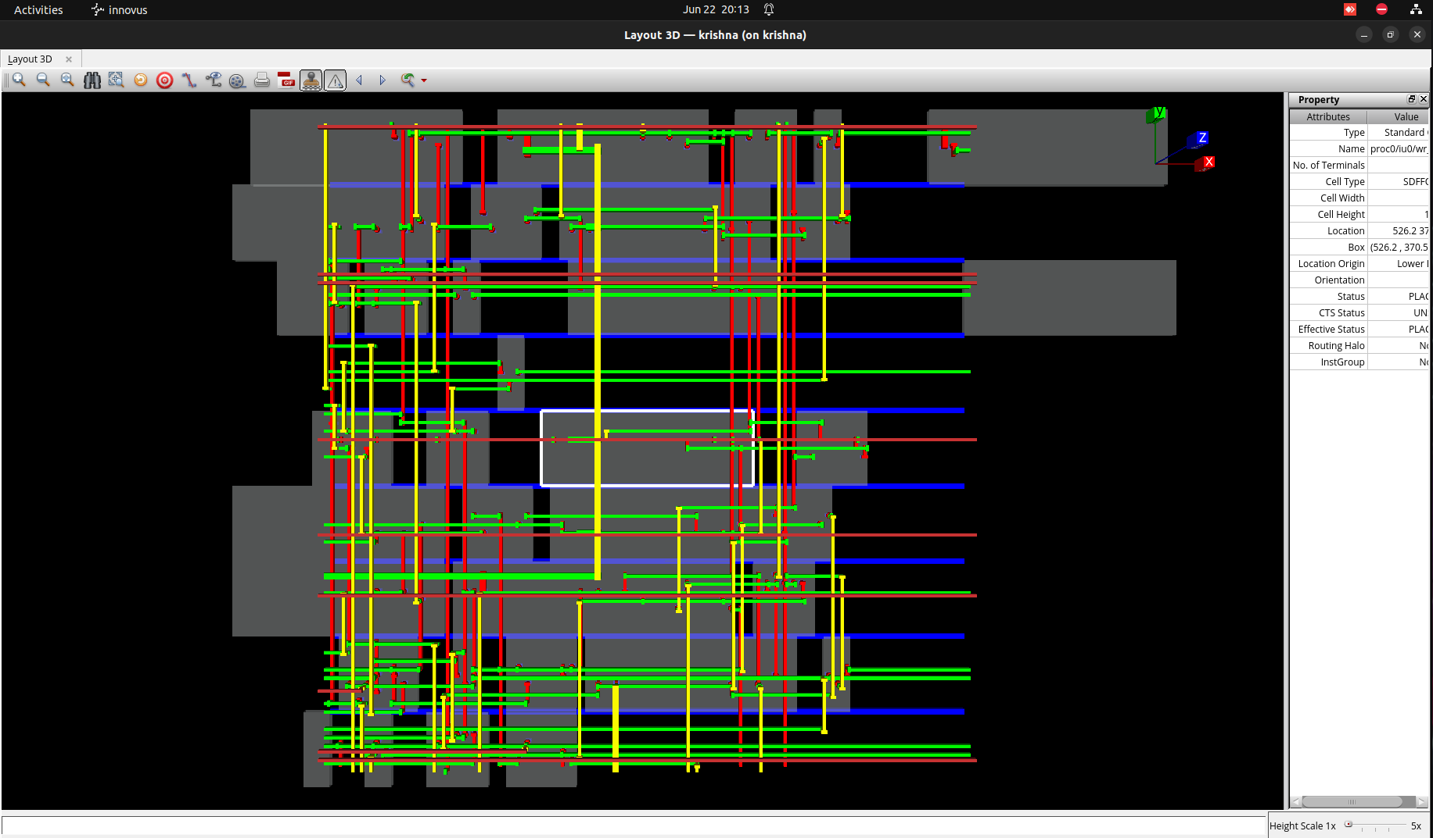
Figure 3.34
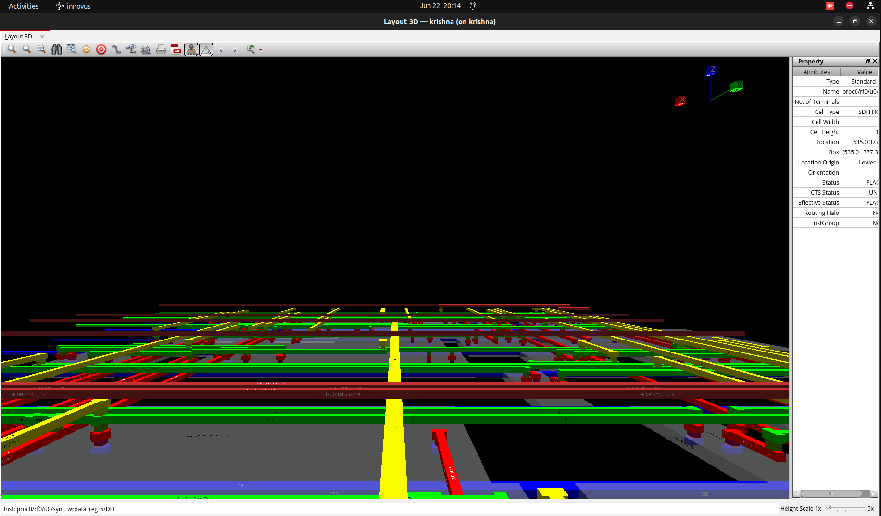
Figure 3.35
Design Verification :

Design verification is a crucial phase in the hardware design process that ensures a design functions correctly and meets all specified requirements before manufacturing. This process employs various methodologies like simulation, formal verification, emulation, and static analysis to rigorously test and validate the design. Simulation applies test vectors to the design to check its outputs, while formal verification uses mathematical methods to prove correctness. Emulation and prototyping validate the design in real-world conditions, and static analysis examines the code for potential issues without executing it. Assertion-based verification and code coverage ensure thorough testing and monitoring of expected behaviors.
A detailed test plan guides these activities, performed within a testbench environment, to ensure all functional, performance, and compliance criteria are met. Continuous regression testing helps identify and fix new bugs introduced by design changes. This comprehensive approach to design verification is essential for producing reliable, high-quality hardware that meets industry standards .

Violation Browser View :
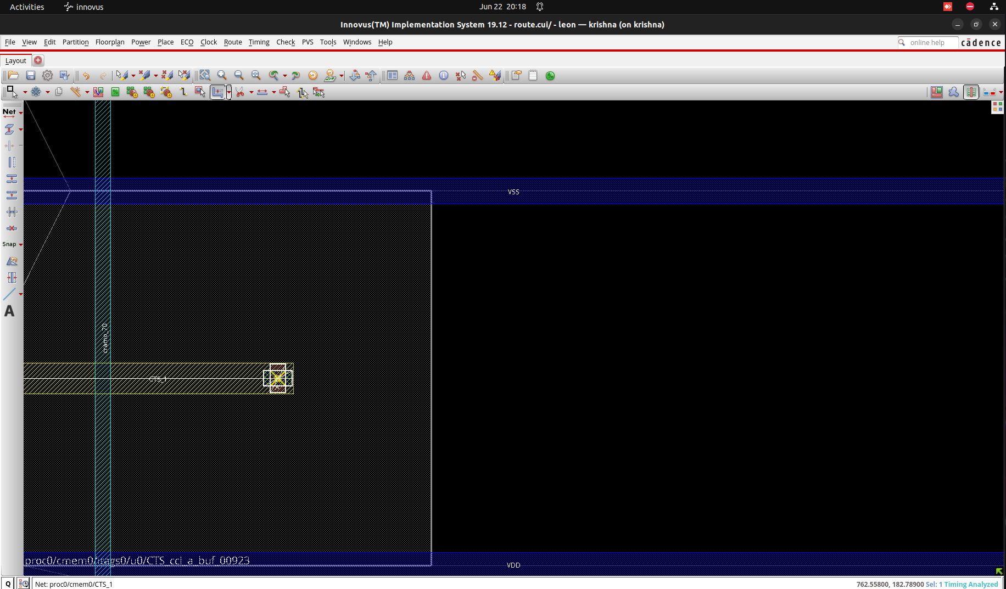
Figure 3.36
Violation Solved :

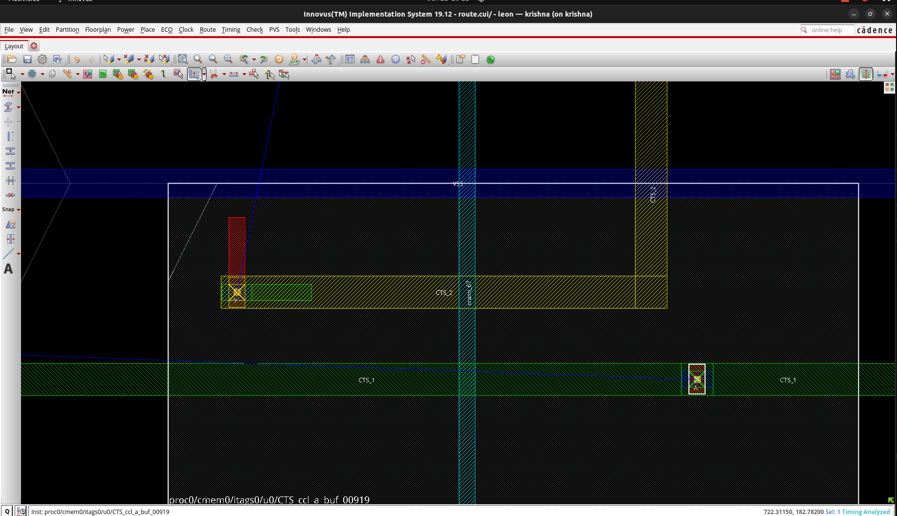
Figure 3.37
4. Results and Discussions

4.1 Test Bench for the RTL Designs

In digital design, a test bench serves as a crucial component for verifying and validating the functionality of Register Transfer Level (RTL) designs before they are implemented in hardware. Essentially, a test bench is a simulation environment that stimulates the RTL design with various input scenarios to ensure it behaves as expected. It consists of a combination of stimuli, which are sets of input signals, and test vectors that represent expected outputs.

The primary goal of a test bench is to thoroughly exercise the RTL design under different conditions, including edge cases and boundary conditions, to detect any functional errors or mismatches between the expected and actual behavior. This rigorous testing process helps designers identify and rectify issues early in the development cycle, thereby enhancing the overall reliability and performance of the digital circuitry before it is fabricated.

(a) Full Adder Test Bench :-

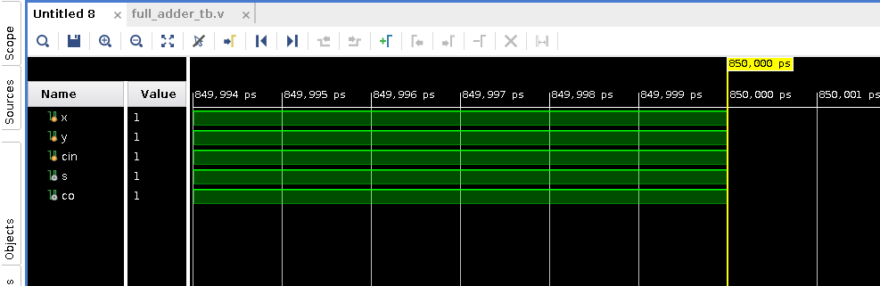
Figure 4.1

(b) Full Subtractor using Full Adder :-

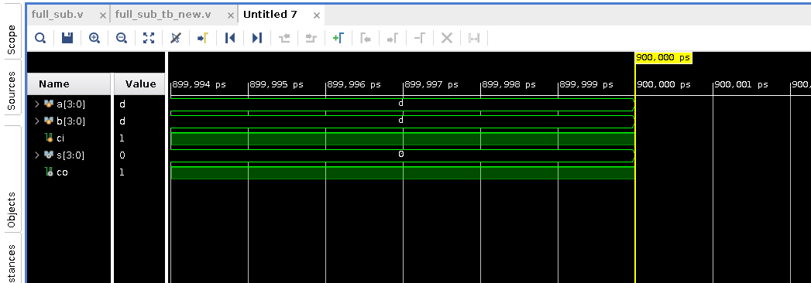
Figure 4.2
(c) 8 Bit ALU Test Bench :-

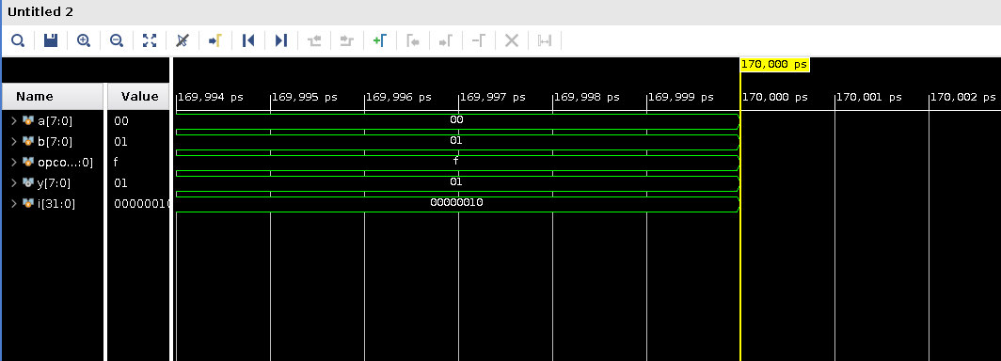
Figure 4.3

(

(d) 4:1 MUX using 2:1 MUX Test Bench :-

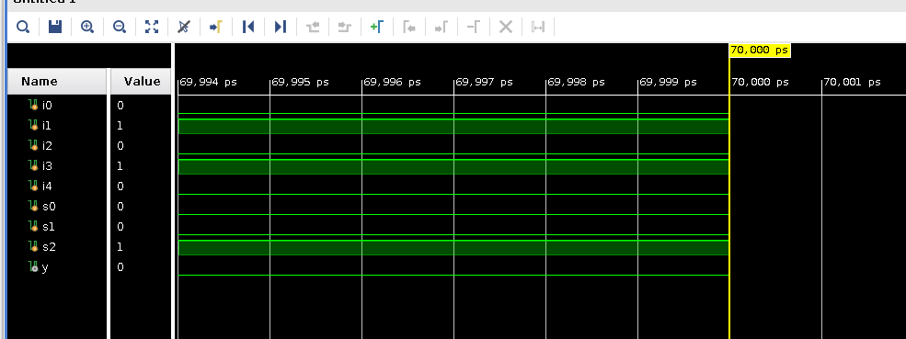
Figure 4.4

(e) Traffic Light Controller Test bench :-
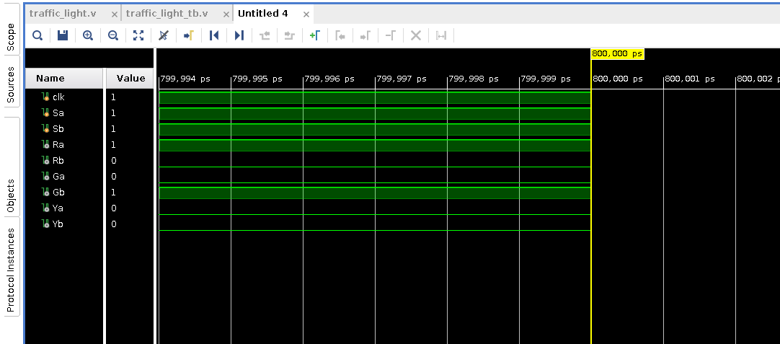

Figure 4.5

(f) Complex Multiplier Test bench :-

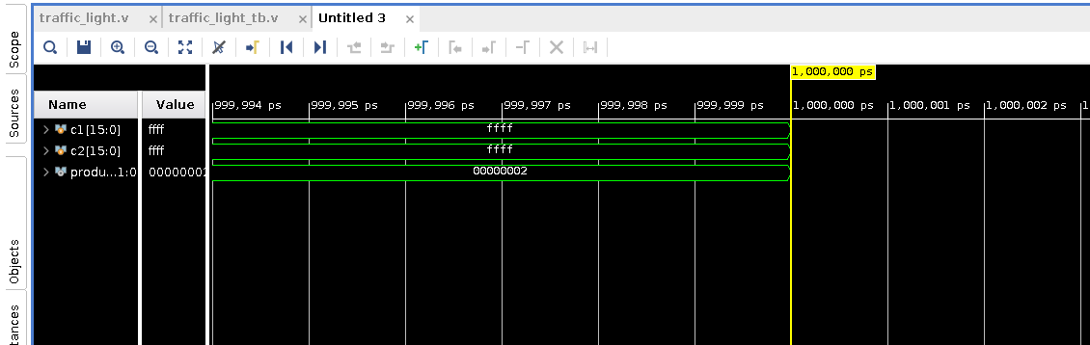
Figure 4.6
(g) Ripple Carry Adder Test Bench :-

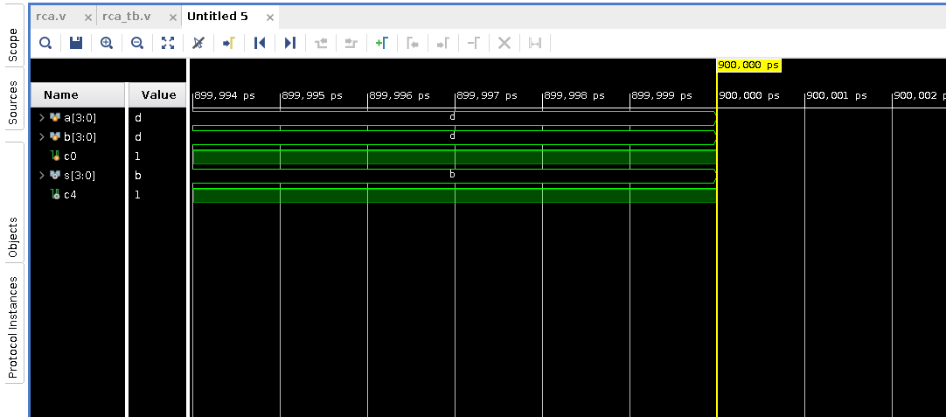
Figure 4.7
4.2 Post synthesis and Post Implementation Table of RTL Designs

(a) Full Adder :-
Post Synthesis |  |  |  | Post Implementation
Resource | Estimation | Available | Utilization % | Resource | Utilization | Available | Utilization %
LUT | 1 | 303600 | 0.01 | LUT | 1 | 303600 | 0.01
IO | 5 | 600 | 0.83 | IO | 5 | 600 | 0.83
Table 4.1

(b) Full Subtractor using Full Adder :-
Post Synthesis |  |  |  | Post Implementation
Resource | Estimation | Available | Utilization % | Resource | Utilization | Available | Utilization %
LUT | 6 | 303600 | 0.01 | LUT | 6 | 303600 | 0.01
IO | 14 | 600 | 2.33 | IO | 14 | 600 | 2.33
Table 4.2

(c) 8 Bit ALU :-

Post Synthesis |  |  |  | Post Implementation
Resource | Estimation | Available | Utilization % | Resource | Utilization | Available | Utilization %
LUT | 248 | 303600 | 0.08 | LUT | 246 | 303600 | 0.08
IO | 28 | 600 | 4.67 | IO | 28 | 600 | 4.67
Table 4.3

(d) 4:1 MUX using 2;1 MUX :-

Post Synthesis |  |  |  | Post Implementation
Resource | Estimation | Available | Utilization % | Resource | Utilization | Available | Utilization %
LUT | 2 | 303600 | 0.01 | LUT | 2 | 303600 | 0.01
IO | 9 | 600 | 1.50 | IO | 9 | 600 | 1.50
Table 4.4

(e) Traffic Light Controller :-

Post Synthesis |  |  |  | Post Implementation
Resource | Estimation | Available | Utilization % | Resource | Utilization | Available | Utilization %
LUT | 7 | 303600 | 0.01 | LUT | 7 | 303600 | 0.01
FF | 4 | 607200 | 0.01 | FF | 4 | 607200 | 0.01
IO | 9 | 600 | 1.50 | IO | 9 | 600 | 1.50
BUFG | 1 | 32 | 3.13 | BUFG | 1 | 32 | 3.13
Table 4.5
(f) Complex Multiplier:-

Post Synthesis |  |  |  | Post Implementation
Resource | Estimation | Available | Utilization % | Resource | Utilization | Available | Utilization %
LUT | 151 | 303600 | 0.05 | LUT | 151 | 303600 | 0.05
IO | 64 | 600 | 10.67 | IO | 64 | 600 | 10.67
Table 4.6
(g) Ripple Carry Adder :-

Post Synthesis |  |  |  | Post Implementation
Resource | Estimation | Available | Utilization % | Resource | Utilization | Available | Utilization %
LUT | 4 | 303600 | 0.01 | LUT | 4 | 303600 | 0.01
IO | 14 | 600 | 2.33 | IO | 14 | 600 | 2.33
Table 4.7
4.3 RTL Design Synthesis Comparison Reports

(a) Comparison Report for dtmf_recvr_core (For 8nS)

Cell and Count Area Comparison
 | LAB 1 | LAB 3
Leaf Instance Count | 4461 | 4415
Physical Instance Count | 0 | 0
Sequential Instance Count | 520 | 560
Combinational Instance Count | 3941 | 3855
Hierarchical Instance Count | 2 | 42
Cell Area | 231945.477 | 232190.110
Physical Cell Area | 0.000 | 0.000
Total Cell Area (Cell+Physical) | 231945.477 | 232190.110
Net Area | 6034.898 | 5688.938
Total Area (Cell+Physical+Net) | 237980.375 | 237799.048
Runtime | 0.0 seconds | 0.0 seconds
Elapsed Runtime | 255 seconds | 242 seconds
Genus peak memory usage | 975.35 | 978.71
Table 4.8
Power Comparison
Library | Instances | Instances % | Area | Leakeage  Power  (nW) | Leakage Power % | Internal Power  (nW) | Internal Power  %
LAB1

CDK_R512x16 | 1 | 0.0 | 9445.288 | 0.000 | 0.0
CDK_S256x16 | 2 | 0.0 | 210487.183 | 0.000 | 0.0
pll | 1 | 0.0 | 32.268 | 0.000 | 0.0
slow_1v0 | 4457 | 99.9 | 11980.739 | 545.514 | 100.0
LAB 3

CDK_R512x16 | 1 | 0.0 | 9445.288 | 0.000 | 0.0 | 0.000 | 0.0
CDK_S256x16 | 2 | 0.0 | 210487.183 | 0.000 | 0.0 | 0.000 | 0.0
pll | 1 | 0.0 | 32.268 | 0.000 | 0.0 | 0.000 | 0.0
slow_1v0 | 4411 | 99.9 | 12225.371 | 411.409 | 100.0 | 296639.696 | 100.0
Table 4.9

LAB1
Type | Instances | Area | Area % | Leakage Power  (nW) | Leakage Power  % | Internal  Power  (nW) | Internal  Power  %
Timing_model | 4 | 219964.739 | 94.8 | 0.000 | 0.0
sequential | 517 | 4033.890 | 1.7 | 165.280 | 30.3
inverter | 372 | 290.700 | 0.1 | 15.893 | 2.9
buffer | 75 | 131.328 | 0.1 | 6.836 | 1.3
logic | 3493 | 7524.821 | 3.2 | 357.505 | 65.5
physical_cells | 0 | 0.000 | 0.0 | 0.000 | 0.0
total | 4461 | 231945.477 | 100.0 | 545.514 | 100.0
Table 4.10
LAB 3
Type | Instances | Area | Area  % | Leakage  Power  (nW) | Leakage  Power  % | Internal  Power  (nW) | Internal  Power  %
timing_model | 4 | 219964.739 | 94.7 | 0.000 | 0.0 | 0.000 | 0.0
sequential | 517 | 4018.842 | 1.7 | 120.965 | 29.4 | 150374.078 | 50.7
inverter | 463 | 342.000 | 0.1 | 12.254 | 3.0 | 2736.918 | 0.9
buffer | 75 | 137.142 | 0.1 | 7.558 | 1.8 | 1489.933 | 0.5
clock_gating_integrated_cell | 40 | 259.920 | 0.1 | 8.663 | 2.1 | 30291.332 | 10.2
logic | 3316 | 7467.467 | 3.2 | 261.610 | 63.6 | 111747.436 | 37.7
physical_cells | 0 | 0.000 | 0.0 | 0.000 | 0.0 | 0.000 | 0.0
total | 4415 | 232190.110 | 100.0 | 411.049 | 100.0 | 296639.696 | 100.0
Tabel 4.11

Final Area
LAB 1

Instance | Module | Cell Count | Cell Area | Net Area | Total Area
dtmf_recvr_core |  | 4461 | 231945.477 | 6034.898 | 237980.375
PM_INST | power_manager | 29 | 76.608 | 32.728 | 109.336
TEST_CONTROL_INST | test_control | 11 | 15.732 | 6.576 | 22.308
LAB 3

dtmf_recvr_core |  | 4415 | 232190.110 | 5608.938 | 237799.048
PM_INST | power_manager | 32 | 99.180 | 31.987 | 131.167
TEST_CONTROL_INST | test_control | 11 | 17.100 | 6.576 | 23.676
Tabel 4.12

Critical Path Slack And Violation Paths
Clock | LAB 1 Period | LAB 3 Period
m_clk | 8000.0 | 8000.0
m_digit_clk | 16000.0 | 16000.0
m_dsram_clk 1 | 16000.0 | 16000.0
m_ram_clk | 16000.0 | 16000.0
m_rcc_clk | 16000.0 | 16000.0
m_spi_clk | 16000.0 | 16000.0
refclk | 8000.0 | 8000.0
Table 4.13

LAB 1 |  |  |  | LAB 3
Cost Group | Critical Path Slack | TNS | Violating Paths | Cost Group | Critical Path Slack | TNS | Violating Paths
default | No paths | 0.0 |  | C2C | 0.1 | 0.0 | 0
m_clk | 2877.6 | 0.0 | 0 | C2O | 7012.8 | 0.0 | 0
m_digit_clk | 7156.6 | 0.0 | 0 | cg_enable_group_m_clk | 2188.5 | 0.0 | 0
m_dsram_clk | 2519.2 | 0.0 | 0 | cg_enable_group_m_rcc_clk | 4502.0 | 0.0 | 0
m_ram_clk | 3417.5 | 0.0 | 0 | cg_enable_group_m_spi_clk | 14899.8 | 0.0 | 0
m_rcc_clk | 3545.2 | 0.0 | 0 | cg_enable_group_refclk | 3327.7 | 0.0 | 0
m_spi_clk | 7156.6 | 0.0 | 0 | default | No paths | 0.0
refclk | 0.1 | 0.0 | 0 | I2C | 3042.3 | 0.0
Total |  | 0.0 | 0 | I2O | No paths | 0.0
 |  |  |  | m_clk | No paths | 0.0
 |  |  |  | m_digit_clk | No paths | 0.0
 |  |  |  | m_dsram_clk | No paths | 0.0
 |  |  |  | m_ram_clk | No paths | 0.0
 |  |  |  | m_rcc_clk | No paths | 0.0
 |  |  |  | m_spi_clk | No paths | 0.0
 |  |  |  | refclk | 7630.1 | 0.0 | 0
 |  |  |  | Total |  | 0.0 | 0
Table 4.144nS
(b) Comparison Report of AMBA APB Bridge

Instance Count and Area Comparison
For 2nS |  |  |  | For 4nS
Cost Group | Critical Path Slack | TNS | Violating Paths | Cost Group | Critical Path Slack | TNS | Violating Paths
default | No paths | 0.0 |  | default | No paths | 0.0
PCLK | -987.6 | -20700.2 | 28 | PCLK | 7012.8 | 0.0 | 0
Total |  | -20700.2 | 28 | Total |  | 0.0 | 0
Table 4.15

 | For 2nS | For 4nS
Leaf Instance Count | 5310 | 1527
Physical Instance Count | 0 | 0
Sequential Instance Count | 260 | 260
Combinational Instance Count | 5050 | 1267
Hierarchical Instance Count | 1 | 1
Cell Area | 21169.903 | 6513.510
Physical Cell Area | 0.000 | 0.000
Total Cell Area (Cell+Physical) | 21169.903 | 6513.510
Net Area | 5892.258 | 2248.433
Total Area (Cell+Physical+Net) | 27062.161 | 8761.943
Runtime | 0.0 secods | 0.0 seconds
Elapsed Runtime | 628 seconds | 85 seconds
Genus peak memory usage | 1079.54 | 951.01
Table 4.16

Final time report
 | 2ns |  | 4nS
 | Slack | Path | Slack | Path
Highest Slack | 404 | 50th | 981 | 50th
Lowest Slack | -988 | 1st | 0 | 3rd
Total Paths | 50 |  | 50
Tabel 4.17

Power Comparison
FOR 2nS
Type | Instances | Area | Area  % | Leakage  Power  (nW) | Leakage  Power  %
sequential | 260 | 2090.646 | 9.9 | 90.231 | 5.8
inverter | 1064 | 2661.102 | 12.6 | 228.485 | 14.7
buffer | 197 | 724.014 | 3.4 | 64.093 | 4.1
unresolved | 1 | 0.000 | 0.0 | 0.000 | 0.0
logic | 3789 | 15694.141 | 74.1 | 1174.713 | 75.4
physical_cells | 0 | 0.000 | 0.0 | 0.000 | 0.0
Total | 5311 | 21169.903 | 100.0 | 1557.522 | 100.0
For 4nS
Type | Instances | Area | Area  % | Leakage  Power  (nW) | Leakage  Power  %
sequential | 260 | 1987.704 | 30.5 | 74.580 | 23.4
inverter | 92 | 261.630 | 4.0 | 23.640 | 7.4
buffer | 19 | 86.526 | 1.3 | 8.098 | 2.5
unresolved | 1 | 0.000 | 0.0 | 0.000 | 0.0
logic | 1156 | 4177.650 | 64.1 | 212.000 | 66.6
physical_cells | 0 | 0.000 | 0.0 | 0.000 | 0.0
Total  Table 4.18 | 1528 | 6513.510 | 100.0 12 pt | 318.318 | 100.0
Report Timing Comparison
 | Capture |  | Launch
 | FOR 2nS | FOR 4nS | FOR 2nS | FOR 4nS
Clock Edge:+ | 2000 | 4000 | 0 | 0
Src Latency:+ | 0 | 0 | 0 | 0
Net Latency:+ | 0 (I) | 0 (I) | 0 (I) | 0 (I)
Arrival:= | 2000 | 0 | 0 | 0
Setup:- | 134 | 91
Uncertainty:- | 300 | 600
Required Time:= | 1566 | 3309
Launch Clock:- | 0 | 0
Data Path:- | 2553 | 3309
Slack:= | -988 | 0
Table 4.19

Report Timing Summary Comparison
SETUP | WNS |  | TNS |  | FEP
 | 2nS | 4nS | 2nS | 4nS | 2nS | 4nS
View: ALL | -987.6 | 0.0 | -20700.2 |  | 28
Group : in2out | N/A | N/A | N/A | N/A | N/A | N/A
Group : in2reg | 404.3 | 980.9 | 0.0 | 0.0 | 0 | 0
Group : reg2out | 1091.9 | 2482.8 | 0.0 | 0.0 | 0 | 0
Group : reg2reg | -987.6 | 0.0 | -20700.2 | 0.0 | 28 | 0
DRV | WNS |  | TNS |  | FEP
 | 2nS |  | 2nS |  | 2nS
View: ALL
Check: max_transition | N/A | N/A | N/A | N/A | 0 | 0
Check: max_capacitance | N/A | N/A | N/A | N/A | 0 | 0
Check: max_fanout | N/A | N/A | N/A | N/A | 0 | 0
Table 4.20

Low Power Flow Report
Type | Instances | Area | Area % | Leakage Power  (nW) | Leakage Power  % | Internal  Power  (nW) | Internal  Power  %
sequential | 11 | 75.582 | 70.6 | 2.202 | 67.7 | 32744.531 | 94.4
inverter | 1 | 0.684 | 0.6 | 0.019 | 0.6 | 0.000 | 0.0
logic | 17 | 30.780 | 28.8 | 1.029 | 31.7 | 1945.258 | 5.6
physical_cells | 0 | 0.000 | 0.0 | 0.000 | 0.0 | 0.000 | 0.0
total | 29 | 107.046 | 100.0 | 3.251 | 100.0 | 34689.790 | 100.0
Gate | Instances | Area | Leakage Power (nW) | Internal Power (nW) | Library
ADDHXL | 1 | 4.788 | 0.158 | 273.588 | slow_1v0
AND2XL | 4 | 5.472 | 0.185 | 268.163 | slow_1v0
AND3XL | 1 | 2.052 | 0.066 | 212.323 | slow_1v0
DFFQXL | 2 | 10.944 | 0.371 | 8606.405 | slow_1v0
DFFRXL | 5 | 42.750 | 1.214 | 22485.021 | slow_1v0
INVXL | 1 | 0.684 | 0.019 | 0.000 | slow_1v0
MX2XL | 2 | 4.788 | 0.162 | 126.649 | slow_1v0
MXI2XL | 1 | 2.394 | 0.066 | 303.527 | slow_1v0
NAND2BXL | 4 | 5.472 | 0.228 | 290.129 | slow_1v0
NOR2BXL | 1 | 1.710 | 0.046 | 191.987 | slow_1v0
NOR2XL | 1 | 1.026 | 0.027 | 85.117 | slow_1v0
NOR3XL | 1 | 1.710 | 0.035 | 126.424 | slow_1v0
OR2XL | 1 | 1.368 | 0.057 | 67.351 | slow_1v0
TLATNXL | 3 | 16.416 | 0.463 | 1407.146 | slow_1v0
TLATXL | 1 | 5.472 | 0.155 | 245.959 | slow_1v0
total | 29 | 107.046 | 3.251 | 34689.790
Table 4.21
(c) Comparison Report for Traffic Light Controller

Timing Comparison

FOR (4 nS):
==========
Path 1: MET (1588 ps) Setup Check with Pin state_reg[1]/CK->D
Group: clk
Startpoint: (F) Sa
Clock: (R) clk
Endpoint: (R) state_reg[1]/D
Clock: (R) clk

FOR (2 nS):
==========
Path 1: MET (78 ps) Setup Check with Pin state_reg[1]/CK->D
Group: clk
Startpoint: (R) state_reg[3]/CK
Clock: (R) clk
Endpoint: (R) state_reg[1]/D
Clock: (R) clk

 | Capture |  | Launch
 | FOR 2nS | FOR 4nS | FOR 2nS | FOR 4nS
Clock Edge:+ | 2000 | 4000 | 0 | 0
Drv Adjust |  | 0 |  | 0
Src Latency:+ | 0 | 0 | 0 | 0
Net Latency:+ | 0 (I) | 0 (I) | 0 (I) | 0 (I)
Arrival:= | 2000 | 4000 | 0 | 0
Setup:- | 77 | 17
Uncertainty:- | 300 | 600
Required Time:= | 1623 | 3383
Launch Clock:- | 0 | 0
Input Delay |  | 480
Data Path:- | 1546 | 1314
Slack:= | 78 | 1588
Table 4.22

Final time report

 | 4nS |  | 2nS
 | Slack | Path | Slack | Path
Highest Slack | 2410 | 6th | 554 | 4th
Lowest Slack | 1588 | 1st | 78 | 1st
Total Paths | 6 |  | 4
Table 4.23

Instance Count And Area Comparison

 | For 4nS | For 2nS
Leaf Instance Count | 27 | 27
Physical Instance Count | 0 | 0
Sequential Instance Count | 4 | 4
Combinational Instance Count | 23 | 23
Hierarchical Instance Count | 0 | 0
Cell Area | 59.850 | 59.850
Physical Cell Area | 0.000 | 0.000
Total Cell Area (Cell+Physical) | 59.850 | 59.850
Net Area | 35.959 | 35.959
Total Area (Cell+Physical+Net) | 95.809 | 95.809
Runtime | 0.0 seconds | 0.0 seconds
Elapsed Runtime | 58 seconds | 24 seconds
Genus peak memory usage  Table 4.24 | 907.49 | 900.02
Power Comparison
For 4nS
Type | Instances | Area | Area  % | Leakage  Power  (nW) | Leakage  Power  %
sequential | 4 | 25.650 | 42.9 | 1.028 | 40.8
inverter | 4 | 2.736 | 4.6 | 0.133 | 5.3
buffer | 1 | 1.710 | 2.9 | 0.085 | 3.4
logic | 18 | 29.754 | 49.7 | 1.275 | 50.6
physical_cells | 0 | 0.000 | 0.0 | 0.000 | 0.0
Total | 27 | 59.850 | 100.0 | 2.522 | 100.0
For 2nS
Type | Instances | Area | Area  % | Leakage  Power  (nW) | Leakage  Power  %
sequential | 4 | 25.650 | 42.9 | 1.028 | 40.8
inverter | 4 | 2.736 | 4.6 | 0.133 | 5.3
buffer | 1 | 1.710 | 2.9 | 0.085 | 3.4
logic | 18 | 29.754 | 49.7 | 1.275 | 50.6
physical_cells | 0 | 0.000 | 0.0 | 0.000 | 0.0
Total  Table 4.25 | 27 | 59.850 | 100.0 | 2.522 | 100.0
 | For 4nS |  |  |  | For 2nS
Gate | Instances | Area | Leakage Power (nW) | Library | Instances | Area | Leakage Power (nW) | Library
AND2X1 | 1 | 1.368 | 0.056 | slow_1v0 | 1 | 1.368 | 0.056 | slow_1v0
AOI21X1 | 1 | 1.710 | 0.081 | slow_1v0 | 1 | 1.710 | 0.081 | slow_1v0
AOI21XL | 1 | 1.710 | 0.041 | slow_1v0 | 1 | 1.710 | 0.041 | slow_1v0
AOI2BB1X1 | 1 | 2.052 | 0.086 | slow_1v0 | 1 | 2.052 | 0.086 | slow_1v0
AOI31X1 | 1 | 2.052 | 0.090 | slow_1v0 | 1 | 2.052 | 0.090 | slow_1v0
BUFX2 | 1 | 1.710 | 0.085 | slow_1v0 | 1 | 1.710 | 0.085 | slow_1v0
DFFHQX1 | 2 | 10.944 | 0.527 | slow_1v0 | 2 | 10.944 | 0.527 | slow_1v0
DFFX1 | 1 | 7.182 | 0.256 | slow_1v0 | 1 | 7.182 | 0.256 | slow_1v0
INVX1 | 4 | 2.736 | 0.133 | slow_1v0 |  | 2.736 | 0.133 | slow_1v0
NAND2X1 | 1 | 1.026 | 0.066 | slow_1v0 | 1 | 1.026 | 0.066 | slow_1v0
NAND3BXL | 1 | 1.710 | 0.076 | slow_1v0 | 1 | 1.710 | 0.076 | slow_1v0
NOR2BX1 | 1 | 1.368 | 0.068 | slow_1v0 | 1 | 1.368 | 0.068 | slow_1v0
NOR2X1 | 1 | 1.026 | 0.049 | slow_1v0 | 1 | 1.026 | 0.049 | slow_1v0
NOR3BXL | 1 | 2.052 | 0.054 | slow_1v0 | 1 | 2.052 | 0.054 | slow_1v0
NOR3X1 | 1 | 1.710 | 0.064 | slow_1v0 | 1 | 1.710 | 0.064 | slow_1v0
NOR3XL | 1 | 1.710 | 0.035 | slow_1v0 | 1 | 1.710 | 0.035 | slow_1v0
OAI21X1 | 1 | 1.710 | 0.081 | slow_1v0 | 1 | 1.710 | 0.081 | slow_1v0
OAI22X1 | 1 | 2.052 | 0.097 | slow_1v0 | 1 | 2.052 | 0.097 | slow_1v0
OAI2BB1 | 1 | 1.710 | 0.089 | slow_1v0 | 1 | 1.710 | 0.089 | slow_1v0
OAI31X1 | 1 | 2.052 | 0.102 | slow_1v0 | 1 | 2.052 | 0.102 | slow_1v0
OR2X1 | 2 | 2.736 | 0.142 | slow_1v0 | 2 | 2.736 | 0.142 | slow_1v0
SDFFQX1 | 1 | 7.524 | 0.245 | slow_1v0 | 1 | 7.524 | 0.245 | slow_1v0
total |  | 59.850 | 2.522 |  | 27 | 59.850 | 2.522
Table 4.26
4.4 Timing Analysis Report of PnR

SET-UP Timing

PRE_CTS

Setup mode | all | reg2reg | reg2cgate | default
WNS (ns): | -1.787 | -1.787 | -0.953 | 0.138
TNS (ns): | -629.997 | -626.018 | -3.979 | 0.000
Violating Paths: | 573 | 568 | 5 | 0
All Paths: | 12271 | 11430 | 31 | 1052
Table 4.27

DRVs | Real |  | Total
DRVs | Nr nets(terms) | Worst Vio | Nr nets(terms)
max_cap | 0 (0) | 0.000 | 0 (0)
max_tran | 1 (42) | -0.022 | 1 (42)
max_fanout | 0 (0) | 0 | 0 (0)
max_length | 0 (0) | 0 | 0 (0)
Table 4.28

Density: 42.512%
Routing Overflow: 0.00% H and 0.00% V

POST_CTS

Setup mode | all | reg2reg | reg2cgate | default
WNS (ns): | -0.104 | -0.104 | 0.180 | 1.823
TNS (ns): | -0.299 | -0.299 | 0.000 | 0.000
Violating Paths: | 5 | 5 | 0 | 0
All Paths: | 12271 | 11430 | 31 | 1052
Table 4.29

DRVs | Real |  | Total
DRVs | Nr nets(terms) | Worst Vio | Nr nets(terms)
max_cap | 0 (0) | 0.000 | 0 (0)
max_tran | 1 (42) | -0.022 | 1 (42)
max_fanout | 0 (0) | 0 | 0 (0)
max_length | 0 (0) | 0 | 0 (0)
Table 4.30
Density: 42.512%
Routing Overflow: 0.00% H and 0.00% V

POST_ROUTE

Setup mode | all | reg2reg | reg2cgate | default
WNS (ns): | 0.060 | 0.060 | 0.378 | 0.378
TNS (ns): | 0.000 | 0.000 | 0.000 | 0.000
Violating Paths: | 0 | 0 | 0 | 0
All Paths: | 12271 | 11430 | 31 | 1052
Table 4.31

DRVs | Real |  | Total
DRVs | Nr nets(terms) | Worst Vio | Nr nets(terms)
max_cap | 0 (0) | 0.000 | 0 (0)
max_tran | 0 (0) | 0.000 | 0 (0)
max_fanout | 0 (0) | 0 | 0 (0)
max_length | 0 (0) | 0 | 0 (0)
Table 4.32

Density: 42.512%
Total number of glitch violations: 0

HOLD Timing

PRE_CTS
Hold mode | all | reg2reg | reg2cgate | default
WNS (ns): | -0.393 | -0.393 | 0.015 | -0.236
TNS (ns): | -285.538 | -280.407 | 0.000 | -5.130
Violating Paths: | 1183 | 1149 | 0 | 34
All Paths: | 11508 | 11430 | 31 | 288
Table 4.33

Density: 42.512%
Routing Overflow: 0.00% H and 0.00% V
------------------------------------------------------------
Reported timing to dir timingReports
Total CPU time: 32.29 sec
Total Real time: 10.0 sec
Total Memory Usage: 2788.300781 Mbytes

POST_CTS

Hold mode | all | reg2reg | reg2cgate | default
WNS (ns): | 0.036 | 0.072 | 0.216 | 0.036
TNS (ns): | 0.000 | 0.000 | 0.000 | 0.000
Violating Paths: | 0 | 0 | 0 | 0
All Paths: | 11508 | 11430 | 31 | 288
Table 4.34

Density: 42.512%
Routing Overflow: 0.00% H and 0.00% V
------------------------------------------------------------
Reported timing to dir timingReports
Total CPU time: 29.14 sec
Total Real time: 6.0 sec
Total Memory Usage: 2778.230469 Mbytes

POST_ROUTE

Hold mode | all | reg2reg | reg2cgate | default
WNS (ns): | 0.019 | 0.072 | 0.210 | 0.019
TNS (ns): | 0.000 | 0.000 | 0.000 | 0.000
Violating Paths: | 0 | 0 | 0 | 0
All Paths: | 11508 | 11430 | 31 | 288
Table 4.35

Density: 42.512%
------------------------------------------------------------
Reported timing to dir timingReports
Total CPU time: 39.52 sec
Total Real time: 9.0 sec
Total Memory Usage: 2976.121094 Mbytes
5. Conclusion and Future Scope

Conclusion
Physical design and RTL design are critical stages in the VLSI design flow, ensuring the successful implementation of complex digital circuits. RTL design focuses on describing the desired functionality and behavior of a system using hardware description languages like Verilog or VHDL. This stage is crucial for defining the logic and verifying the correctness of the design through simulation. On the other hand, physical design translates the RTL code into a geometrically accurate layout that can be fabricated on silicon. It involves placement, routing, timing analysis, and design rule checks to ensure the design meets performance, power, and area specifications.
Throughout this report, we have explored the methodologies and tools used in both RTL and physical design, highlighting their importance in the overall design flow. By understanding and mastering these stages, engineers can create efficient, reliable, and high-performance integrated circuits.

Future Scope
The future of physical and RTL design is poised for significant advancements driven by emerging technologies and evolving industry demands. Key areas of focus include:
- Automation and AI Integration: The integration of artificial intelligence and machine learning techniques in design automation tools will revolutionize RTL and physical design. AI can optimize design parameters, predict potential issues, and suggest improvements, significantly reducing design time and improving efficiency.
- Advanced Node Technologies: As the semiconductor industry progresses towards smaller technology nodes, RTL and physical design methodologies must adapt to handle increased complexity, variability, and power constraints. Innovations in FinFET, GAA, and other advanced node technologies will require new design strategies and tools.
- 3D ICs and Heterogeneous Integratio12 ptn: The development of 3D integrated circuits and heterogeneous integration techniques offers new opportunities for enhancing performance and reducing power consumption. RTL and physical design processes will need to evolve to support these multi-dimensional design paradigms, addressing challenges in thermal management, interconnect design, and reliability.
- Security and Reliability: With the increasing prevalence of IoT and connected devices, ensuring the security and reliability of integrated circuits is paramount. Future design methodologies will incorporate advanced techniques for hardware security, fault tolerance, and resilience against cyber-attacks.
- Quantum and Neuromorphic Computing: Emerging computing paradigms such as quantum computing and neuromorphic computing present unique challenges and opportunities for RTL and physical design. Developing design flows and tools tailored to these technologies will be essential for realizing their potential in practical applications.
In conclusion, the fields of physical and RTL design are at the forefront of enabling technological advancements in the semiconductor industry. By embracing new technologies, methodologies, and tools, designers can continue to push the boundaries of what is possible, creating more powerful, efficient, and secure integrated circuits for the future.

References

1 Cadence ,”Genus Common UI Lab Instructions Rapid Adoption Kit (RAK)”, Product Version Genus 19.1 (2019)
2. Cadence ,”Basic Floorplanning in Innovus using Stylus Common UI Rapid Adoption Kit (RAK)”, Product Version :Innovus version 22.1x ( 2023)
3. Cadence ,”Block Implementation Flow using Stylus Interface of Innovus Rapid Adoption Kit (RAK)”, Product Version :Innovus 18.1( 2018)
Canonical Ltd. (2023). Ubuntu. Retrieved from https://ubuntu.com
Vim Documentation. (2023). Vim - the ubiquitous text editor. Retrieved from https://www.vim.org
- Ubuntu Documentation. (2023). Official Ubuntu Documentation. Retrieved from https://help.ubuntu.com
- Vim Users Wiki. (2023). Vim Tips Wiki. Retrieved from https://vim.fandom.com/wiki/Vim_Tips_Wiki
- Linux Documentation Project. (2023). The Linux Documentation Project. Retrieved from http://www.tldp.org
- RTL Design and RTL to GDS II Flow Overview. (2023). Retrieved from various industry sources and technical documentation on digital IC design and fabrication processes.
Synopsys Inc. (2023). Design Compiler: RTL Synthesis Tool. Retrieved from https://www.synopsys.com/implementation-and-signoff/rtl-synthesis/design-compiler-rtl-synthesis.html
- Cadence Design Systems Inc. (2023). Genus Synthesis Solution. Retrieved from https://www.cadence.com/en_US/home/tools/digital-design-and-signoff/synthesis.html
- Cadence Design Systems Inc. (2023). JasperGold Formal Verification Platform. Retrieved from https://www.cadence.com/en_US/home/tools/system-design-and-verification/formal-and-static-verification/jasper-gold.html
- Synopsys Inc. (2023). Formality: Formal Verification Tool. Retrieved from https://www.synopsys.com/verification/static-and-formal-verification/formality.html
- Cadence Design Systems Inc. (2023). Innovus Implementation System. Retrieved from https://www.cadence.com/en_US/home/tools/digital-design-and-signoff/soc-implementation-and-floorplanning/innovus-implementation-system.html
- Synopsys Inc. (2023). IC Compiler II: Place-and-Route Solution. Retrieved from https://www.synopsys.com/implementation-and-signoff/place-and-route.html
- Synopsys Inc. (2023). PrimeTime: Static Timing Analysis Tool. Retrieved from https://www.synopsys.com/implementation-and-signoff/signoff/primetime.html
- Cadence Design Systems Inc. (2023). Tempus Timing Signoff Solution. Retrieved from https://www.cadence.com/en_US/home/tools/digital-design-and-signoff/signoff-and-design-analysis/tempus-timing-signoff-solution.html
- IEEE Xplore. (2023). Design for Manufacturability Techniques. Retrieved from https://ieeexplore.ieee.org
- Research Papers and Journals on High-Level Synthesis, Formal Verification, and Physical Design Techniques.
Cadence Design Systems Inc. (2023). Innovus Implementation System. Retrieved from https://www.cadence.com/en_US/home/tools/digital-design-and-signoff/soc-implementation-and-floorplanning/innovus-implementation-system.html
- Synopsys Inc. (2023). IC Compiler II: Place-and-Route Solution. Retrieved from https://www.synopsys.com/implementation-and-signoff/place-and-route.html
- Mentor Graphics (Siemens EDA). (2023). Olympus-SoC: Physical Implementation System. Retrieved from https://eda.sw.siemens.com/en-US/ic/olympus-soc/
- Synopsys Inc. (2023). PrimeTime: Static Timing Analysis Tool. Retrieved from https://www.synopsys.com/implementation-and-signoff/signoff/primetime.html
- Cadence Design Systems Inc. (2023). Tempus Timing Signoff Solution. Retrieved from https://www.cadence.com/en_US/home/tools/digital-design-and-signoff/signoff-and-design-analysis/tempus-timing-signoff-solution.html
- Mentor Graphics (Siemens EDA). (2023). Calibre: Physical Verification Tool. Retrieved from https://eda.sw.siemens.com/en-US/ic/calibre/
- Synopsys Inc. (2023). IC Validator: Physical Verification Tool. Retrieved from https://www.synopsys.com/implementation-and-signoff/signoff/ic-validator.html
- Cadence Design Systems Inc. (2023). Pegasus Verification System. Retrieved from https://www.cadence.com/en_US/home/tools/digital-design-and-signoff/signoff-and-design-analysis/pegasus-verification-system.html
- Synopsys Inc. (2023). Power Compiler: Power Optimization Tool. Retrieved from https://www.synopsys.com/implementation-and-signoff/signoff/power-compiler.html
- ANSYS Inc. (2023). RedHawk: Power and Thermal Analysis Tool. Retrieved from https://www.ansys.com/products/electronics/ansys-redhawk
- Cadence Design Systems Inc. (2023). Voltus IC Power Integrity Solution. Retrieved from https://www.cadence.com/en_US/home/tools/digital-design-and-signoff/signoff-and-design-analysis/voltus-ic-power-integrity-solution.html
- Research Papers and Journals on physical design methodologies, published in IEEE Xplore and other technical journals.
Synopsys Inc. (2023). Design Compiler: RTL Synthesis Tool. Retrieved from https://www.synopsys.com/implementation-and-signoff/rtl-synthesis/design-compiler-rtl-synthesis.html
- Cadence Design Systems Inc. (2023). Genus Synthesis Solution. Retrieved from https://www.cadence.com/en_US/home/tools/digital-design-and-signoff/synthesis.html
- IEEE Xplore. (2023). RTL Design Methodologies. Retrieved from https://ieeexplore.ieee.org
- Cadence Design Systems Inc. (2023). Verilog and VHDL for RTL Design. Retrieved from https://www.cadence.com/en_US/home/tools/system-design-and-verification/rtl-simulation.html
- Mentor Graphics (Siemens EDA). (2023). ModelSim HDL Simulation. Retrieved from https://eda.sw.siemens.com/en-US/ic/modelsim/
Cadence Design Systems Inc. (2023). Innovus Implementation System. Retrieved from https://www.cadence.com/en_US/home/tools/digital-design-and-signoff/soc-implementation-and-floorplanning/innovus-implementation-system.html
- Cadence Design Systems Inc. (2023). Innovus User Guide. Retrieved from https://resources.cadence.com/content/dam/cadence-www/global/en_US/documents/tools/digital-design-signoff/innovus-implementation-user-guide.pdf
- Cadence Design Systems Inc. (2023). Innovus Stylus Machine Learning Capabilities. Retrieved from https://www.cadence.com/en_US/home/tools/digital-design-and-signoff/soc-implementation-and-floorplanning/innovus-machine-learning.html
- Cadence Design Systems Inc. (2023). Digital Full Flow with Innovus. Retrieved from https://www.cadence.com/en_US/home/tools/digital-design-and-signoff/full-flow.html

